**VISION-BASED OBJECT DETECTION AND DISTANCE CALCULATION IN AUTONOMOUS VEHICLES**

*Report submitted to the SASTRA Deemed to be University*

*in partial fulfilment of the requirements*

*for the award of the degree of*

Bachelor of Technology

*Submitted by*

**SOWMIYA G**

**(Reg. No.: 225003144, BTech-CSE)**

**KURUBA BHAVYASREE**

**(Reg. No.: 225003193, BTech-CSE)**

**MANTHRA P M**

**(Reg. No.: 225003208, BTech-CSE)**

**May 2025**



**DEPARTMENT OF COMPUTER SCIENCE AND ENGINEERING**

**SRINIVASA RAMANUJAN CENTRE**

**KUMBAKONAM, TAMIL NADU,**

**INDIA – 612001**



**DEPARTMENT OF COMPUTER SCIENCE AND ENGINEERING**

**SRINIVASA RAMANUJAN CENTRE**

**KUMBAKONAM, TAMIL NADU,**

**INDIA – 612001**

**Bonafide Certificate**

This is to certify that the project report titled “**Vision-Based Object Detection and Distance Calculation in Autonomous Vehicles**” submitted in partial fulfilment of the requirements for the award of the degree of **B. Tech. Computer Science and Engineering** to the SASTRA Deemed to be University, is a bona-fide record of the work done by **Ms. SOWMIYA G** (Reg. No. 225003144) **Ms.** **KURUBA BHAVYASREE** (Reg. No. 225003193) **Ms. MANTHRA P M** (Reg. No. 225003208)during the final semester of the academic year 2024-25, in the Department of Computer Science and Engineering, Srinivasa Ramanujan Centre, under my supervision. This report has not formed the basis for the award of any degree, diploma, associateship, fellowship or other similar title to any candidate of any University.

**Signature of Project Supervisor :**

**Name with Affiliation : Dr. G Revathy/AP-III/CSE**

**Date :**

Project *Viva voc*e held on ________________

Examiner 1 Examiner 2



**DEPARTMENT OF COMPUTER SCIENCE AND ENGINEERING**

**SRINIVASA RAMANUJAN CENTRE**

**KUMBAKONAM, TAMIL NADU, INDIA – 612001**

**Declaration**

We declare that the project report titled “**Vision-Based Object Detection and Distance Calculation in Autonomous Vehicles**” submitted by us is an original work done by us under the guidance of **Dr. G Revathy/AP-III/CSE, Srinivasa Ramanujan Centre, SASTRA Deemed to be University** during the final semester of the academic year 2024-25, in theSrinivasa Ramanujan Centre. The work is original and wherever we have used materials from other sources, we have given due credit and cited them in the text of the report. This report has not formed the basis for the award of any degree, diploma, associate-ship, fellowship or other similar title to any candidate of any University.

**Signature of the candidates :**

**Name of the candidates : Sowmiya G Kuruba Bhavyasree Manthra P M**

**Date :**

**ACKNOWLEDGEMENTS**

We pay our sincere obeisance to God Almighty for his grace and infinite mercy and for showing us his choicest blessings.

We would like to express our gratitude to **Prof. R. Sethuraman, Chancellor, Dr. S. Vaidhyasubramaniam, Vice Chancellor, Dr. R. Chandramouli, Registrar, and Dr. S. Swaminathan, Dean- Planning and Development,** for providing us with the opportunity to be students of this esteemed institution.

We express our deepest gratitude to **Dr. V. Ramaswamy, Dean, and Dr. A. Alli Rani, Associate Dean, Srinivasa Ramanujan Centre**, for their constant support and suggestions, which were provided without reservation.

We express our gratitude to **Dr. V. Kalaichelvi/ACP/CSE, Srinivasa Ramanujan Centre,** for her constant support and valuable suggestions for the completion of the project.

We exhibit our pleasure in expressing our thanks to **Dr G Revathy/AP/CSE,** our guide for her ever-encouraging spirit and meticulous guidance for the completion of the project.

We would like to place on record the benevolent approach and painstaking guidance and correction of **Dr. S. Ranjeeth Kumar/AP/CSE,** the project coordinator and all department staff to whom we owe our heartfelt thanks forever.

Without the support of our parents and friends, this project would never have become a reality.

We dedicate this work to our well-wishers, with love and affection.

**Table of Contents**

**Title Page No.**

Bona-fide Certificate ii

Declaration iii

Acknowledgments iv

List of Figures vii

Abbreviations ix

Notations x

Abstract xi

1. Summary of base paper 1

1.1. Introduction to base paper approach 1

1.2. proposed method in base paper 1

1.3. Merits of base paper 2

1.4. Demerits of base paper 2

1.5. Introduction to proposed method 3

1.6. Literature survey 4

1.7. Objective 5

1.8. Existing System 5

1.9. Proposed System 6

1.10. Scope of the Project 6

1.11. Software and Hardware Requirements 7

1.12. Methodology 7

1.13. Tools and Technologies used 8

1.14. Advantages and Disadvantages 9

1.15. Conclusion 10

2.Objective 11

2.1 Problem Formulation 11

3.Methodology and experimental work 13

3.1 Data Collection and Preparation 13

3.2 Model Development and Validation Strategy 13

|  |
| --- |
|  |

|  |
| --- |
| 3.3. Architecture Design of Predictive Models 14 |
| 3.4. Frontend Dashboard and Visualisation 16  3.5 Model Performance Analysis and Comparative Study 17 |

4.Results and Discussions 20

|  |
| --- |
| 4.1. Evaluation metrics and Results 20 |
| 4.2. YOLOv5 Result 22 |
| 4.3. YOLOv8 Result 28 |
| 4.4. SSD Result 29 |
| 4.5. Hybrid Approach-KITTI Dataset Result 31  4.6 Hybrid Approach-Custom Dataset Result 32 |

4.7 Object detection and distance estimation Results 33

4.8 Model Comparison 35

4.9 Front End 36

5.Conclusion and plans 37

6.References 39

7.Appendix 41

7.1 Base Paper 41

7.2 Sample Source Code 59

**List of Figures**

|  |  |  |
| --- | --- | --- |
| **Figure No.** | **Title** | **Page No.** |
| 1.1 | Flow diagram of the proposed strategy. | 2 |
| 2.1 | Problem Formulation | 12 |
| 3.1 | YOLOv5 Architecture | 15 |
| 3.2 | YOLOv8 Architecture | 15 |
| 3.3 | SSD Architecture | 16 |
| 4.1 | Summary of YOLOv5s model | 22 |
| 4.2 | Confusion matrix | 22 |
| 4.3 | Precision Curve | 23 |
| 4.4 | Recall Curve | 23 |
| 4.5 | Summary of YOLOv5n model | 23 |
| 4.6 | Confusion matrix | 24 |
| 4.7 | Precision Curve | 24 |
| 4.8 | Recall Curve | 24 |
| 4.9 | Summary of YOLOv5m model | 25 |
| 4.10 | Confusion matrix | 25 |
| 4.11 | Precision Curve | 26 |
| 4.12 | Recall Curve | 26 |
| 4.13 | Summary of YOLOv5l model | 26 |
| 4.14 | Confusion matrix | 27 |
| 4.15 | Precision Curve | 27 |
| 4.16 | Recall Curve | 27 |
| 4.17 | Summary of YOLOv8 model | 28 |
| 4.18 | Confusion matrix | 28 |
| 4.19 | Precision Curve | 29 |
| 4.20 | Recall Curve | 29 |
| 4.21 | Summary of SSD model | 29 |

|  |  |  |
| --- | --- | --- |
| **Figure No.** | **Title** | **Page No.** |
| 4.22 | Confusion matrix | 30 |
| 4.23 | Precision Curve | 30 |
| 4.24 | Recall Curve | 30 |
| 4.25 | Confusion matrix-Hybrid model(KITTI) | 31 |
| 4.26 | Precision Curve-Hybrid model(KITTI) | 31 |
| 4.27 | Recall Curve-Hybrid model(KITTI) | 31 |
| 4.28 | Confusion matrix-Hybrid model(Custom) | 32 |
| 4.29 | Precision Curve-Hybrid model(Custom) | 32 |
| 4.30 | Recall Curve-Hybrid model(Custom) | 32 |
| 4.31 | object detection | 33 |
| 4.32 | object detection | 33 |
| 4.33 | object detection | 33 |
| 4.34 | distance estimation | 34 |
| 4.35 | distance estimation | 34 |
| 4.36 | distance estimation | 34 |
| 4.37 | Comparison of models | 35 |
| 4.38 | YOLOv5 model front end | 36 |
| 4.39 | YOLOv8 model front end | 36 |

**ABBREVIATIONS**

AI Artificial Intelligence

F1-Score Harmonic Mean of Precision and Recall

FN False Negative

FP False Positive

Google collab Google Collaboratory (Cloud-based Jupyter Notebook)

GPU Graphics Processing Unit

IoU Intersection over Union

KITTI Dataset Name

mAP mean Average Precision

Matplotlib Mathematical Plotting Library

ms milliseconds

Numpy Numerical Python

OpenCV Open Source Computer Vision Library

Pandas Python Data Analysis Library

PR curve Precision-Recall curve

PyTorch Python Torch (Deep Learning Framework)

Seaborn Statistical Data Visualization Library

SSD Single Shot Multibox Detector

TN True Negative

TP True Positive

YOLO You Only Look Once

**NOTATIONS**

x,y Centre coordinates of the bounding box (in pixels)

w Width of the bounding box (in pixels

h Height of the bounding box (in pixels)

d Estimated distance to the detected object

Iou Overlap measure between predicted and ground truth boxes

mAP@ 0.5 Mean average precision at IoU threshold 0.5

[mAP@0.5:0.95](mailto:mAP@0.5:0.95) mean average precision averaged over Iou thresholds 0.5 to 0.95

C Confidence score of object detection

Loss Total loss (sum of box, objectness, and class losses)

box_loss loss related bounding box regression accuracy

obj_loss loss related to objectness (confidence score)

cls_loss loss related to class prediction accuracy

p(c) probability of class c

^y​ predicted label

y Ground truth label

σ Sigmoid Function

**ABSTRACT**

Object detection and distance estimation are key technologies for enabling autonomous systems to navigate and interact with their environments effectively. This project is aimed at developing and testing algorithms for simultaneous object detection and distance estimation in indoor autonomous vehicles. The proposed method will utilize YOLOv5 and its variants, as well as YOLOv8 and SSD models, for obstacle detection and distance estimation with a single monocular camera, without requiring further calibration. Training will be performed on a combination of existing datasets, such as KITTI, and a custom-labelled indoor environment dataset. Data augmentation and transfer learning techniques will be used to improve model performance and adaptability. The project will compare and evaluate these methods in order to provide a reliable and cost-effective solution for the accurate detection of obstacles and distance estimation in indoor environments.

**Keywords:** object detection, YOLO, SSD, distance estimation, autonomous vehicles

**Specific Contribution:**

* KURUBA BHAVYASREE: She focused on implementing YOLOv5 (s and l variants) and YOLOv8n for object detection in indoor environments. She was involved in training, validation, and comparative evaluation of these models. Additionally, she developed a hybrid detection pipeline combining YOLOv5 and YOLOv8 outputs using datasets to enhance accuracy. She also contributed significantly to annotating and augmenting the custom dataset.
* SOWMIYA G: She implemented the YOLOv5n and SSD models for object detection and evaluated their performance on kitti dataset. She was actively involved in training, validation, and performance analysis of both models. Her work also included visualizing detection outputs and integrating them with simulated distance estimation.
* MANTHRA P M: She implemented the YOLOv5m model and assisted in SSD and hybrid model integration for object detection. She was actively involved in training, validation, and performance analysis. she actively contributed to collecting the custom outdoor dataset.

**Specific Learning**

* KURUBA BHAVYASREE: Gained practical expertise in YOLOv5 (s, l) and YOLOv8 model training, inference, and evaluation. Developed skills in object detection pipeline integration and annotation handling. Strengthened knowledge in performance metric analysis and hybrid model fusion techniques.
* SOWMIYA G: Acquired knowledge in training and optimizing YOLOv5 and SSD models. Improved understanding of model comparison, bounding box evaluation, and mAP-based performance tuning.
* MANTHRA P M: Learned custom dataset collection and preprocessing for outdoor environments. Gained experience in YOLOv5m model deployment and hybrid model experimentation.

**CHAPTER 1**

**SUMMARY OF BASE PAPER**

**Title:** Vision-Based Object Detection and Distance Calculation in Autonomous Vehicles

**Journal Name:** Electronics

**Authors:** Iker Azurmendi, Ekaitz Zulueta, Jose Manuel Lopez-Guede, Manuel González

**Available online:** 21 November 2023

* 1. **INTRODUCTION TO BASE PAPER APPROACH**

The base paper presents a hybrid object detection and distance estimation framework for autonomous navigation in indoor environments. The approach combines state-of-the-art object detection models (YOLOv5) to enhance accuracy. It introduces a custom dataset tailored for detection outputs are integrated with a depth estimation model to calculate the distance to detected objects. This pipeline improves obstacle awareness and supports reliable navigation in complex indoor scenarios.

* 1. **PROPOSED METHOD IN BASE PAPER**

**1.2.1 Object Detection Using YOLOv5**

The proposed method utilizes a modified YOLOv5 architecture for real-time object detection. YOLOv5 is chosen for its balance of speed and accuracy, making it well-suited for use in indoor autonomous vehicles.

**1.2.2 Distance Estimation**

In addition to object detection, the model is modified to estimate the distance between the camera and the detected objects. This is achieved by extending the prediction output of the YOLOv5 model, enabling it to simultaneously perform object detection and distance estimation from a single monocular image**.**

**1.2.3 Dataset and Transfer Learning**

The model is initially trained on the KITTI dataset for general detection and distance tasks. To tailor it to an indoor environment, a custom dataset of 104 images was collected and used for transfer learning. Data augmentation techniques were applied to improve robustness.

**1.2.4 Performance Evaluation**

The final YOLOv5m model, after training and fine-tuning, achieved.  
This confirms the effectiveness of the proposed approach for simultaneous object detection and distance estimation in indoor settings**.**

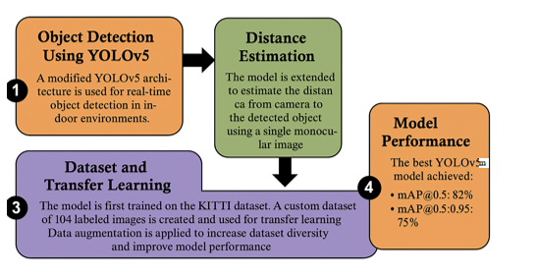

Fig. 1.1 Flow diagram of the proposed strategy.

* 1. **MERITS OF BASE PAPER**

**1.3.1 Simultaneous Detection and Estimation**

Proposes a novel architecture that integrates object detection and distance estimation using a single YOLOv5m model, reducing hardware complexity.

**1.3.2 Cost-Effective Implementation**

Uses only a single monocular, uncalibrated camera, which makes it low-cost and easy to deploy compared to LiDAR or stereo vision systems.

**1.3.3 Customizable**

Can be trained for different indoor environments with minimal data.

**1.3.4 Accurate and Fast**

Provides a balance between speed and accuracy, suitable for real-time applications on resource-constrained devices**.**

* 1. **DEMERITS OF BASE PAPER**
     1. **Limited Dataset and Obstacle Types**

The model is trained and evaluated only on a small indoor dataset with a single obstacle type (humans), which may limit generalizability.

**1.4.2 No Real-Time Obstacle Avoidance Module**

While detection and distance estimation are covered, the paper does not implement or test an actual obstacle avoidance strategy.

**1.4.3 Dependency on Manual Labelling**

The creation of a custom dataset with labelled distances requires manual effort and measurement, which is time-consuming

* 1. **INTRODUCTION TO PROPOSED METHOD**

The quick pace of autonomous system development has spurred extensive interest in the creation of low-cost, effective navigation solutions for indoor spaces. Unlike outdoor autonomous vehicles that take advantage of GPS and LiDAR technologies, indoor systems operate under special limitations where miniaturization, low cost, and vision are critical. For such systems, obstacle detection and range estimation are vital for efficient and safe navigation, particularly in applications where manual intervention is being substituted by mobile robotic platforms.

The established techniques based on LiDAR, stereo vision, or radar provide accurate range measurements but with the penalty of added complexity, calibration, and hardware costs. These constraints necessitate vision-based techniques that are capable of performing well with low numbers of sensors—especially monocular cameras, which are inexpensive, lightweight, and simple to deploy.

New advances in deep learning, especially object detection architectures like the YOLO family, have created new prospects for real-time perception in robots. YOLOv5, which has a good balance between speed and accuracy, is one of the top contenders for object detection tasks in dynamic environments. The models are typically aimed at object classification and localization but do not have inherent abilities to estimate distance.

To fill this lacuna, the current study proposes a revised deep learning model from YOLOv5 optimized for both object detection and distance estimation in a single monocular camera. The model architecture is improved by incorporating a regression part into the prediction vector, which allows it to predict the distance of each object detected without using extra sensors or calibration steps. This dual-task learning strategy simplifies the perception pipeline, which is particularly suitable for indoor autonomous vehicles.

The model is trained on a mix of the publicly released KITTI dataset and a self-collected indoor dataset. Data augmentation methods are utilized to augment the self-collected dataset, and transfer learning is employed to fine-tune the model for the indoor domain. The performance of the suggested method is measured with typical performance metrics such as mean Average Precision (mAP) on object detection and Mean Absolute Error (MAE) on distance estimation, showing the ability of the model to execute both tasks accurately and effectively in real indoor environments.

This study improves the accuracy of detecting objects and estimating distances, while also showing how AI can be effectively used in autonomous navigation. By combining deep learning with practical techniques, the research helps create smarter, safer, and more efficient systems for indoor autonomous vehicles.

* 1. **LITERATURE SURVEY**
* A study titled *"Simultaneous Object Detection and Distance Estimation for Indoor Autonomous Vehicles" [1]* proposed a deep learning-based system combining YOLOv7 for detection and ESRGAN for image enhancement. It achieved high accuracy on a custom dataset using transfer learning and data augmentation. However, the model's performance is sensitive to image quality and requires substantial computational resources.
* A 2023 paper in *Multimedia Tools and Applications [2]* explored object detection in adverse weather conditions for autonomous vehicles. The authors leveraged different YOLOv5 variants to address low visibility. While effective, the complexity of model selection for deployment remains a challenge.
* Research on *"Vehicle Detection and Traffic Density Estimation Using Ensemble of Deep Learning Models"* [3] published in *Electronics (2023)* proposed a hybrid model combining SSD and Faster R-CNN. The ensemble improved detection accuracy and traffic flow predictions. The disadvantage is increased computational complexity and longer inference times.
* A 2022 study in *Multimedia Tools and Applications [4]* proposed a cost-effective object detection and distance estimation framework using a monocular camera. The model utilized transfer learning and a custom dataset, offering accurate predictions. Limitations include lower resolution from upscaling and high computational demands.
* The classic *YOLO* (You Only Look Once) model introduced in *IEEE Access (2016)* [5] framed detection as a regression problem, offering real-time performance and generalized object representations. However, it struggles with small or nearby object localization.
* A 2020 article in *IEEE Access* [6] proposed a deep CNN-based framework for moving object detection, showing improved accuracy and speed, especially with Tiny YOLOv3. However, deep learning methods face challenges with background modeling in high-resolution scenes.
* An *IEEE Access (2023[7])* study presented a reinforcement learning-based A2C approach for object detection using both image features and object count as labels. This method adapts to new environments without bounding boxes but lacks classification capability and requires pre-trained evaluation models.
* The *DETR* (Detection Transformer) [8] model from *ECCV 2020* introduced an end-to-end set-based transformer detection architecture. It simplifies implementation and matches Faster R-CNN accuracy but is computationally intensive.
* *EfficientDet* from *IEEE Access (2020) [9]* integrated BiFPN and compound scaling with EfficientNet. It achieved fast inference, state-of-the-art accuracy on COCO, and improved Pascal VOC segmentation results. Nonetheless, it may require fine-tuning for specific use cases.
* An improved *YOLOv8n* model for foreign-object detection in power transmission lines (IEEE Access, 2024) incorporated ECA attention mechanisms and small object detection modules. It demonstrated improved accuracy but may still suffer in highly cluttered scenes or require substantial training data.
  1. **OBJECTIVE**

The core goal of the base paper is to create a lightweight, precise, and scalable deep learning-based system for simultaneous object detection and distance estimation in indoor autonomous vehicles based on a single monocular camera. Acknowledging the weakness of conventional sensor-based systems, including LiDAR and stereo vision—which are usually expensive, computationally demanding, and need to be complicatedly calibrated—the research aspires to introduce a low-cost alternative via vision-based perception.

The study particularly addresses adapting the YOLOv5 architecture to forecast not just object classes and bounding boxes but also the distance to each detected object, without any need for camera calibration or special sensors. The goal is reached by adding a distance regression module to the YOLOv5 model prediction vector and transferring it using transfer learning methods.

Another primary objective is to experiment with the developed method on both the KITTI dataset and a custom indoor dataset, utilizing data augmentation and transfer learning for further improving the model performance even in data-restricted settings. The performance of the model is evaluated using indicators like mean Average Precision (mAP) for object detection and Mean Absolute Error (MAE) for estimating distances.

Furthermore, the research seeks to perform a comparative performance analysis between various YOLOv5 versions (n, s, m, l) to identify the most efficient model in the aspects of accuracy and inference speed. Through successful detection and distance estimation at a low setup, the work supports the overall objective of providing safe, autonomous navigation in indoor spaces like factories, hospitals, and warehouses.

In conclusion, the foundation paper aims to show that a monocular vision-based system, driven by deep learning, can provide an effective and scalable solution for real-time obstacle detection and distance estimation—enabling smarter and more responsive indoor mobile robots.

**1.8 Existing System**

Existing obstacle detection and distance estimation frameworks in self-driving cars primarily depend on specific sensors like LiDAR, stereo cameras, or ultrasonic sensors. Though these methods guarantee good depth accuracy, they hugely elevate the cost of hardware, computation, and total system integration effort—particularly for indoor spaces where space and budget are serious considerations. Moreover, most classical object detection architectures only detect and locate objects and fail to estimate their distance.

**1.8.1 Sensor-Based Detection Techniques**

Current techniques often employ stereo vision, RGB-D cameras, or LiDAR for estimating distance. These techniques are good but need calibration, several hardware components, and intensive processing. They are typically inappropriate for light-weight, low-cost indoor robots. Although there are some monocular techniques, they typically employ pre-mapped scenes or known object sizes, which restricts flexibility and accuracy.

**1.8.2 Drawbacks**

Classical systems are slow to process real-time, particularly on low-power embedded platforms. Sensor fusion configurations are costly, large, and sensitive to conditions like lighting or surface reflectance. Monocular vision solutions are cheap but weak in robustness and need additional calibration or environmental constraints. Majority of current models also consider object detection and depth estimation as isolated tasks, hence causing inefficiency and higher latency.

**1.9 Proposed System**

The base paper presents a deep learning-based approach for simultaneous object detection and distance estimation from a single monocular camera, optimized for indoor autonomous navigation. The framework adapts the YOLOv5 architecture to incorporate a distance regression block, without needing external sensors or calibration.

**1.9.1 Dataset-Driven Feature Learning**

The suggested method employs the KITTI dataset and a locally-collected indoor dataset to train the detection and estimation pipeline. Data augmentation methods are used to expand the size and diversity of the training set in order to make the model stronger in real-world indoor scenes. The method allows the system to generalize well across diverse scenes with minimal labelled data.

**1.9.2 Lightweight and Scalable Architecture**

The system examines various YOLOv5 variants (n, s, m, l) to strike a balance between detection precision and computation. Transfer learning facilitates the system to perform accurately even on limited data, while retaining real-time inferencing speeds. This renders the solution ideal for running on low-power embedded platforms deployed in indoor autonomous vehicles.

**1.10 Scope of the Project**

The scope of this project is mainly on developing a real-time, low-cost, and scalable perception system for indoor autonomous vehicles using a deep learning framework based on monocular vision. By modifying and extending the YOLOv5 object detection architecture, the system is designed to perform simultaneous object detection and distance estimation without the need for additional sensors such as LiDAR or stereo cameras.

The solution is optimized for deployment in indoor environments like warehouses, hospitals, and smart factories, where space and computational resources may be limited. The proposed system utilizes transfer learning and data augmentation techniques to ensure adaptability across various scenes and lighting conditions, making it robust even with relatively small, domain-specific datasets**.**

**1.11 Software and Hardware Requirements**

**1.11.1 Software Requirements**

The development of the proposed object detection and distance estimation system relies on a modern software stack that supports deep learning, image preprocessing, and model evaluation. The core programming language is Python, chosen for its extensive libraries and ease of integration.

* PyTorch – for implementing and modifying the YOLOv5 architecture.
* OpenCV – for image preprocessing and visualization tasks.
* Pandas & NumPy – for data manipulation, annotation handling, and numerical computations.
* Matplotlib & Seaborn – for performance metric visualization, including PR curves and confusion matrices.
* Albumentations – for applying advanced data augmentation techniques.
* Jupyter Notebook & Google Colab – for interactive development, visualization, and testing.

Model training and experimentation can be conducted locally or on cloud platforms

(e.g.,Google Colab) that offer GPU acceleration.

**1.11.2 Hardware Requirements**

Due to the computational intensity of deep learning and optimization algorithms, the system must meet certain hardware standards. Minimum of 8 GB RAM and a multi-core CPU (Intel i5/i7 or AMD Ryzen5/7) is recommended, though 16 GB RAM or more ensures better performance during training. GPU acceleration, ideally with an NVIDIA CUDA-enabled GPU like GTX 1650 or higher, significantly improves model training time. SSD storage and good thermal management are also advised for efficient data access and reliable system performance, especially during extended training and real-time inference**.**

**1.12 Methodology**

**1.12.1 Data Collection**

This project uses two datasets: one is the popular KITTI dataset, and the other is a custom indoor dataset with 104 images. These indoor images show everyday objects and include labels for object type and how far they are from the camera.

**1.12.2 Data Augmentation**

To make the indoor dataset bigger and more useful, we apply changes to the images like flipping, changing brightness, adding noise, and sharpening. This helps the model learn better in different indoor conditions. After these changes, we end up with five times more images.

**1.12.3 Model Design**

We use a model called YOLOv5 for detecting objects. We change the model slightly so it can also predict how far away the object is, not just what it is or where it is. We also update the model's training to include this distance information.

**1.12.4 Training the Model**

First, we train the model using the KITTI dataset so it can learn general object detection. Then we fine-tune it using our custom indoor images. This helps the model adjust to indoor environments. We use standard training methods to make sure it learns well.

**1.12.5 Evaluation**

We test the model to see how well it detects objects and estimates distances. For detection, we check accuracy using precision, recall, F1-score, and mAP at IOU 0.5 and 0.95. We also compare different versions of the YOLOv5 model to find the best one.

**1.13 Tools and Technologies Used**

**1.13.1 Programming Languages**

The primary programming language used in this project is **Python**, due to its wide adoption in the deep learning community and its rich ecosystem of libraries that support computer vision, data processing, and model evaluation. Python enables efficient implementation of object detection models, training workflows, and visualization tools. All model development, including modifications to the YOLOv5 architecture, training scripts, and evaluation routines, is conducted in Python using open-source frameworks.

**1.13.2 Libraries and APIs**

* **PyTorch:**
  + Used to build and train the modified YOLOv5 architecture.
  + Provides GPU acceleration and dynamic computation graphs for deep learning.
* **OpenCV:**
  + Employed for image preprocessing and annotation format conversion.
  + Supports operations like resizing, cropping, and drawing bounding boxes**.**
* **NumPy & Pandas:**
  + Used for efficient data manipulation and numerical computations.
  + Helpful for handling dataset labels and converting formats**.**
* **Albumentations:**
  + Applied for advanced data augmentation (e.g., flipping, brightness, noise).
  + Increases dataset diversity to improve model generalization**.**
* **Matplotlib & Seaborn:**
  + Used for visualizing training performance, confusion matrices, and PR curves.
  + Help interpret model behaviour and compare results across versions**.**

**1.14 Advantages and Disadvantages**

**1.14.1 Advantages**

The proposed system offers a cost-effective and lightweight solution for real-time object detection and distance estimation using a single monocular camera. By integrating distance prediction into the YOLOv5 architecture, it eliminates the need for expensive sensors like LiDAR or stereo cameras. The use of data augmentation and transfer learning enhances performance even with limited indoor data. The model is capable of accurately detecting obstacles and estimating distances in varied indoor settings, making it highly suitable for compact mobile robots. Its scalable architecture and fast inference speed enable easy integration into real-world autonomous systems.

**1.14.2 Disadvantages**

Despite its efficiency, the system does have some limitations. Its performance can be sensitive to lighting conditions and object occlusions, which may affect detection accuracy in certain environments. The reliance on manually labelled distance data in the custom dataset adds to the effort and time required for dataset preparation.

Additionally, the modified YOLOv5 architecture with added distance regression increases the complexity of model training and tuning. While less resource-intensive than sensor-based systems, training still requires GPU support for acceptable performance, which may not be feasible on all platforms.

**1.15 Conclusion**

**1.15.1 Summary**

The baseline paper presents an efficient and practical deep learning-based method for conducting simultaneous object detection and distance estimation with a single monocular camera. By adapting the YOLOv5 architecture to have a distance regression output, the model is able to detect objects accurately and estimate the distance of objects in real-time without depending on auxiliary sensors such as LiDAR or stereo cameras. Utilizing both the KITTI dataset and a personal indoor dataset, along with data augmentation and transfer learning, guarantees the model to generalize over different environments. The system performs robustly in terms of mAP and MAE ensuring good detection and distance estimation, making it a good solution for indoor autonomous navigation.

**1.15.2 Future Enhancement**

Future improvements can focus on enhancing the model’s adaptability to more complex and dynamic indoor environments by integrating real-time scene adaptation techniques. Incorporating additional deep learning components like attention mechanisms or transformer-based modules could help the model handle occlusions and small objects more effectively. Deployment on edge devices such as NVIDIA Jetson Nano or Raspberry Pi can also be explored by optimizing and compressing the model for low-power inference. Furthermore, expanding the dataset with more diverse indoor scenes and automating distance labelling using depth sensors could improve both training efficiency and accuracy. Long-term, this framework could be extended to outdoor environments or integrated with path planning systems for complete end-to-end autonomous navigation.

**CHAPTER 2 OBJECTIVE**

**2.1 PROBLEM FORMULATION**

Accurate obstacle detection and distance estimation are critical for the safe and efficient operation of autonomous vehicles, particularly in constrained indoor environments such as warehouses, hospitals, and smart manufacturing facilities. Traditional methods rely heavily on LiDAR, stereo vision, or ultrasonic sensors, which, while effective, are often costly, power-intensive, and difficult to scale in compact or low-resource settings. Furthermore, these systems typically require complex calibration procedures and are not always suitable for dynamic indoor navigation.

To address these limitations, this project proposes a deep learning-based hybrid framework that uses only a single monocular camera for both object detection and distance estimation. The system is trained and evaluated using a combination of the KITTI dataset and a custom indoor dataset specifically captured to reflect real-world indoor obstacle scenarios. The custom dataset is expanded through data augmentation techniques to improve model robustness and diversity.

The model architecture integrates various pretrained object detection models—YOLOv5 (in s, m, n, and l variants), YOLOv8, SSD and hybrid approach—along with a depth estimation module that calculates object distances based on detected bounding boxes. By training on Kitti and custom datasets, the system is optimized to handle a range of object types and spatial contexts. Performance is evaluated using metrics such as Precision, Recall, F1-score, and mAP at IoU thresholds of 0.5 and 0.95, with results visualized through confusion matrices and precision-recall curves.

The formulated problem focuses on developing an accurate, real-time, and scalable solution that reduces hardware dependency while maintaining high performance for object detection and distance estimation. The ultimate goal is to support intelligent decision-making and navigation for autonomous indoor vehicles, with the potential for deployment in low-cost.

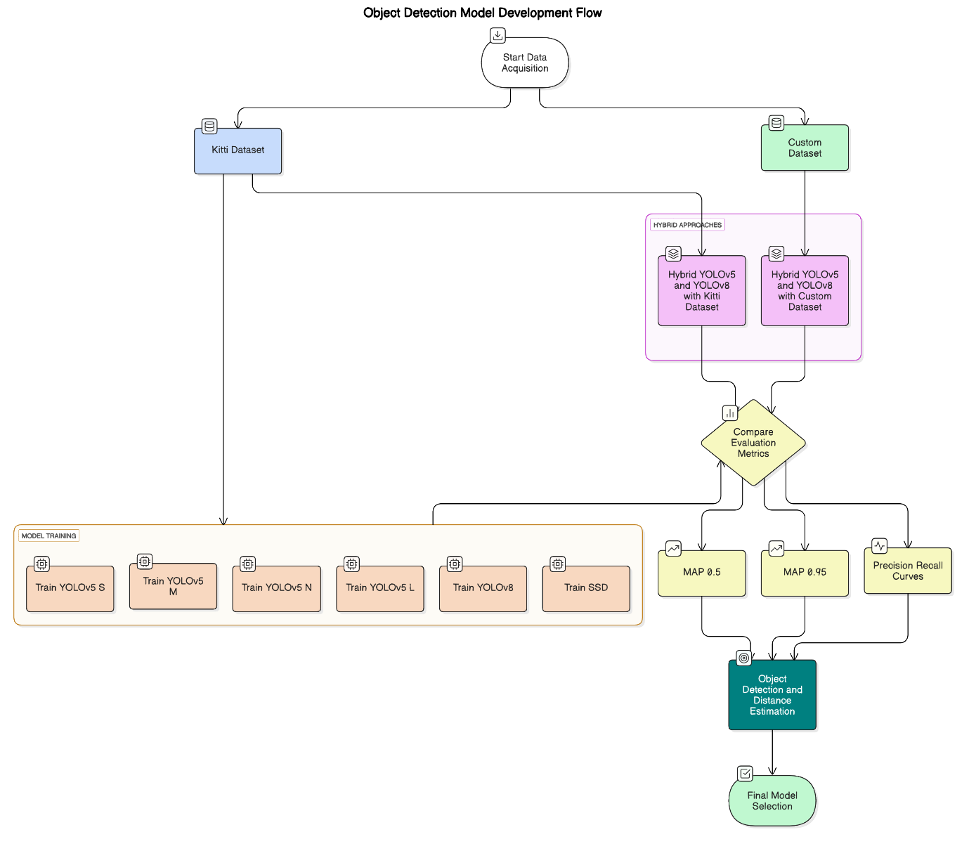

Fig. 2.1 Problem formulation

**CHAPTER 3**

**METHODOLOGY AND EXPERIMENTAL WORK**

**3.1 Data Collection and Preparation**

The foundation of this project is built on the acquisition and preprocessing of high-quality image datasets for object detection and distance estimation in indoor environments. Two datasets were used: the publicly available KITTI dataset, which provides labelled outdoor scenes for object detection and depth estimation, and a custom dataset specifically collected for this study. This dataset captures various obstacle scenarios in environments such as outside streets and platforms, using a monocular camera setup. Each image was manually annotated with object labels and their corresponding distances, measured using a laser rangefinder.

Given the relatively small size of the custom dataset, comprehensive preprocessing and augmentation techniques were applied to enhance data diversity and model robustness. The key preprocessing steps include:

* Data Augmentation: Horizontal flipping, brightness adjustments, Gaussian noise addition, and contrast variations were applied to increase the dataset from 100 to 300 annotated images.
* Annotation Formatting: Object labels and distance values were converted into formats compatible with the YOLO and SSD object detection models.
* Image Resizing and Normalization: All images were resized to a standard input resolution of 640×640 pixels, and pixel values were normalized to improve model training efficiency.
* Class Label Mapping: A consistent labelling scheme was established across both datasets to ensure compatibility during model training and evaluation.

The prepared datasets were then split into training and testing sets, ensuring a balanced representation of different obstacle types and scenes. The resulting image sets and annotations served as the primary inputs to the deep learning models for training, fine-tuning, and performance evaluation**.**

**3.2 Model Development and Validation Strategy**

To enable accurate and real-time object detection and distance estimation in autonomous vehicles, this project employs a series of advanced deep learning models specifically designed for image-based visual perception. The focus is on selecting models that are optimized for speed, accuracy, and adaptability to varying environments, while minimizing the need for expensive sensor setups.

The following models were developed and evaluated:

* **YOLOv5 (s, m, n, l variants):** A family of object detection models offering different trade-offs between accuracy and inference speed. The smaller variants (n and s) are ideal for real-time deployment on resource-limited devices, while the larger versions (m and l) provide improved accuracy for complex scenes.
* **YOLOv8:** A more recent version of the YOLO architecture that incorporates updated design principles for improved detection accuracy and training stability. YOLOv8 builds on the efficiency of its predecessors and adds features like anchor-free detection and better label assignment.
* **SSD (Single Shot MultiBox Detector):** A fast and lightweight object detection model that predicts object classes and bounding boxes in a single forward pass. SSD is used as a comparative baseline to YOLO-based approaches.
* **Hybrid Model (YOLOv5 + YOLOv8**): A combined architecture that leverages the strengths of both YOLOv5 and YOLOv8, trained jointly on the KITTI and custom datasets. This model aims to improve both detection robustness and distance estimation accuracy by integrating multi-scale features.

**Training Strategy:**

* The dataset (KITTI + custom dataset) was split into training, testing and validation subsets, ensuring a balanced representation of obstacle types and scenarios.70:20:10 ratio was used to preserve the integrity of evaluation.
* Transfer Learning was applied by initializing the models with pretrained weights, enabling faster convergence and better generalization to indoor environments.
* Early stopping was used during training to prevent overfitting, halting the process when validation loss stopped improving over multiple epochs.
* Batch normalization and data augmentation were employed to stabilize training and improve robustness to variations in lighting and object orientation.
* Hyperparameters such as learning rate, batch size, and number of epochs were tuned manually based on validation performance and resource constraints**.**

**3.3 Architecture Design of Models**

Each model was architecturally fine-tuned to optimize performance based on its computational capabilities and learning mechanism:

**YOLOv5 (s, m, n, l):**

* One-stage object detection model using CSPNet backbone and PANet neck.
* Architecturally varied to offer trade-offs between speed (YOLOv5n/s) and accuracy (YOLOv5m/l).
* Used for precise object detection; distance estimation is performed using a depth estimation model that takes YOLO-detected bounding boxes as input.
* Tuned with learning rate, batch size, image size, and confidence threshold.
* Pretrained weights fine-tuned on the custom dataset for improved generalization across different object types and scenes.

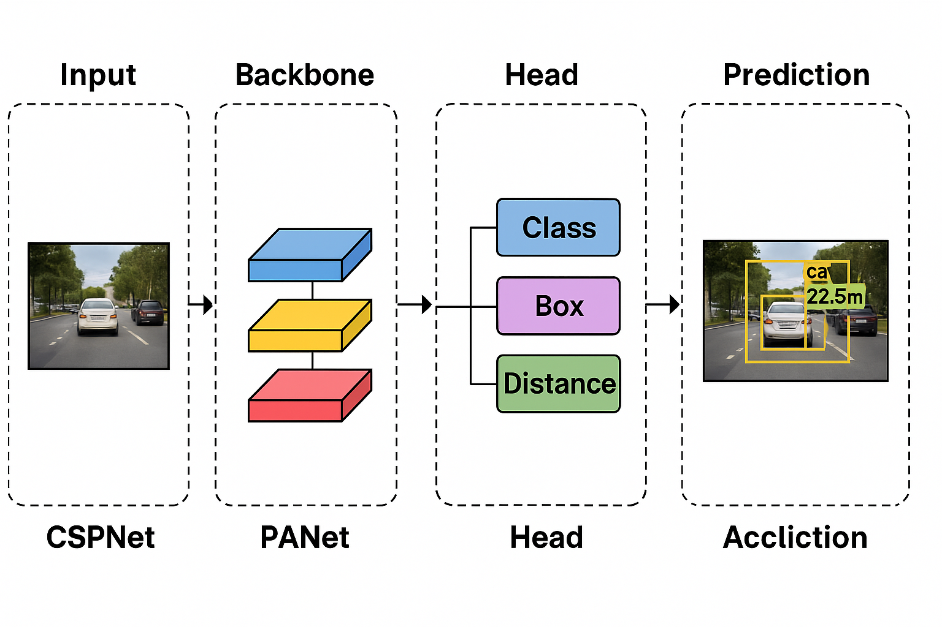

**Fig. 3.1 YOLOv5**

**YOLOv8:**

* Latest YOLO version with anchor-free detection and adaptive label assignment.
* Optimized using early stopping, learning rate scheduling, and dropout regularization.
* Performs strongly in complex detection scenarios when fine-tuned on both datasets.

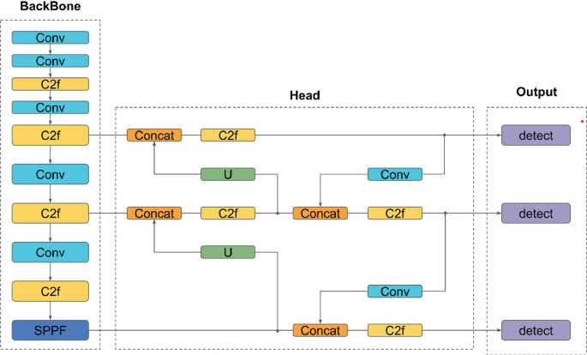

**Fig. 3.2 YOLOv8**

**SSD (Single Shot Multibox Detector):**

* One-stage object detector using multiple feature maps and default anchor boxes.
* Provides fast detection with moderate accuracy, making it ideal for baseline comparison.
* Lightweight and suitable for real-time applications on limited hardware.
* Used to evaluate performance relative to more advanced YOLO models.

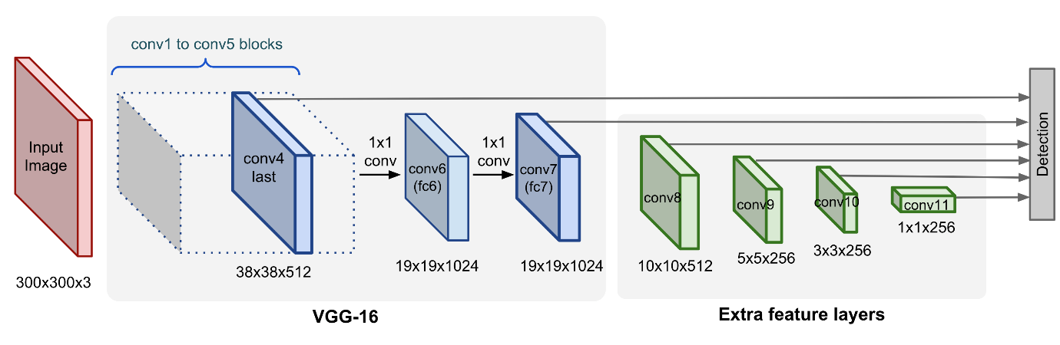

**Fig. 3.3 SSD Model**

**Hybrid Model (YOLOv5 + YOLOv8):**

* Combines outputs from YOLOv5 and YOLOv8 to leverage strengths of both architectures.
* Trained on both KITTI and the custom dataset for enhanced generalization and robustness.
* Final predictions and distance estimations are fused using post-processing logic.
* Offers a balanced solution for real-time object detection with reliable distance estimation.

**3.4 Frontend Dashboard and Visualization**

As a way of making the object detection and estimation of distance more user-friendly and accessible, Streamlit was employed to create an interactive frontend dashboard. The interactive frontend dashboard is designed to support users such as developers, researchers, or even robotics engineers, in uploading image data or loading real-time camera feeds, select object detection models, and see results immediately rendered with bounding boxes and estimated distance.

**Key Features:**

**Image Input and Camera Interface:**

Both static images can be uploaded or the webcam on the user's device is used to supply real-time input to the detection system. The dashboard processes the input automatically and delivers annotated results.

**Model Selection Panel:**

An easy dropdown interface allows users to switch between various models—YOLOv5 (variants) and YOLOv8—to see how each model performs on one type of input. This facilitates comparison of model accuracy, detection speed, and distance estimation visually.

**Detection Output Display:**

After processing, the dashboard shows the input image with bounding boxes around recognized objects, labelled with the class of the object and its approximated distance from the camera. This gives instantaneous visual feedback and makes model testing easier.

**Interactive Widgets:**

**Model Selector Dropdown:** Enables users to select between YOLOv5 and YOLOv8 models.

**File Uploader / Camera Toggle:** Provides the flexibility to test the models against uploaded images or live video streams.

**Result Panel:** Shows annotated outputs with the names of objects and the predicted distances well overlaid.

The frontend system fills in the gap between technical deployment and practical usability by offering an easy-to-use interface to interact with and try out the models. It becomes the critical element in the demonstration of the real-time functionality of the proposed object detection and distance estimation system**.**

**3.5 Model Performance Analysis and Comparative Study**

After training and deploying each object detection model, a comprehensive performance analysis was conducted using industry-standard metrics such as Precision, Recall, F1-Score, mean Average Precision (mAP@0.5 and mAP@0.5:0.95), and inference speed. These evaluations were performed on both the KITTI dataset and the custom dataset, providing insight into each model’s real-world applicability and accuracy.

**Findings:**

* **YOLOv5l** showed the best overall performance with mAP@0.5 of 0.858 and mAP@0.5:0.95 of 0.675 on the KITTI dataset. It had high per-class accuracy and low inference time (8.0 ms/image), making it ideal for high-precision applications.
* **YOLOv5m** also performed strongly, achieving mAP@0.5 of 0.881 and mAP@0.5:0.95 of 0.701, with balanced precision and recall. It offered a good trade-off between speed (6.6 ms inference) and accuracy.
* **YOLOv5s** demonstrated fast processing (4.4 ms inference) and solid detection performance with mAP@0.5 of 0.852 and mAP@0.5:0.95 of 0.660. It is suitable for edge deployment where speed is crucial.
* **YOLOv5n**, the lightest variant, achieved lower mAP values (mAP@0.5 of 0.746, mAP@0.5:0.95 of 0.530) but delivered the fastest inference speed (3.0 ms/image). It's optimal for low-power devices with limited resources.
* **YOLOv8** introduced an anchor-free architecture and improved label assignment, producing a mAP@0.5 of 0.814 and mAP@0.5:0.95 of 0.609, with a very fast inference time of 1.9 ms/image. It performed particularly well in recall (up to 0.942 for Pedestrian class) but slightly lower in precision compared to YOLOv5l and YOLOv5m, showing its strength in detecting more objects quickly, though at some cost to accuracy.
* **SSD:** SSD achieved a mAP@0.5 of 0.111 and mAP@0.5:0.95 of 0.111, with a precision of 0.211 and recall of 0.127. It was very fast, with an inference time of 2.5 ms/image. Overall, SSD was good for fast detection but had lower accuracy compared to other models.

**Hybrid Model (YOLOv5 + YOLOv8 – KITTI Dataset, 200–300 images):**

* **Precision**: 0.4157
* **Recall**: 0.8043
* **F1-Score**: 0.5481
* **mAP@0.5**: 0.3344
* **mAP@0.5:0.95**:0.1912  
  This combined model showed high recall, meaning it was good at finding most objects. However, since it was trained on only a small portion of the KITTI dataset, its precision and mAP scores were lower due to more false positives and limited training depth.

**Hybrid Model (YOLOv5 + YOLOv8 – Custom Dataset, 200–300 images):**

* **Precision**: 0.2000
* **Recall**: 0.7703
* **F1-Score**: 0.3175
* **mAP@0.5**: 0.1541
* **mAP@0.5:0.95**:0.0800
* With a small custom dataset, the hybrid model could still detect many objects (good recall), but it struggled with accuracy (low precision) and overall performance (low mAP). This shows that while the model can detect obstacles, it needs more training data to improve its confidence and precision in indoor settings.

**Comparative Insights:**

* YOLOv5l remains the most accurate overall model in terms of mAP performance, offering strong detection across all classes.
* **YOLOv8** delivers the fastest inference and strong recall, making it ideal for applications requiring quick object detection with acceptable accuracy.
* **YOLOv5m** provides a well-balanced trade-off between accuracy and speed, suitable for most general-purpose deployments.
* YOLOv5s and YOLOv5n are optimized for real-time systems with limited computational power, offering fast predictions with moderate accuracy.
* The Hybrid model (YOLOv5 + YOLOv8) showed promising recall but lower precision and mAP, largely due to the limited training size of just 200–300 images used from both the KITTI and custom datasets**.**
* **SSD** provides very fast inference but lower overall accuracy, making it suitable for real-time applications where speed is more critical than detection precision.
* Final Recommendation:
* If you need **speed and can tolerate slightly less precision → YOLOv8**
* If your goal is **balanced performance on moderate hardware and high accuracy→ YOLOv5m**

All models were evaluated under consistent conditions using the same dataset splits, ensuring a fair and meaningful comparison. The insights drawn support model selection for specific deployment needs, whether for edge devices, high-accuracy use, or rapid inference in constrained environments.

**CHAPTER 4**

**RESULTS AND DISCUSSIONS**

**4.1 EVALUATION METRICS AND RESULTS**

In this project, the performance of several deep learning models—YOLOv5 (s, m, n, l variants), YOLOv8, SSD, and a hybrid YOLOv5+YOLOv8 approach—was evaluated for the dual tasks of object detection and distance estimation. The models were trained and tested primarily on the KITTI dataset, and the hybrid model was also tested on a custom dataset containing 200–300 images and also 200 -300 images from KITTI dataset . To ensure robust and fair evaluation, a set of widely accepted metrics in object detection was used.

**4.1.1 Precision**

Precision measures how many of the predicted objects were correctly identified. It is calculated as the ratio of True Positives to the sum of True Positives and False Positives:

Precision= ​ TP/TP+FP

**Interpretation:**  
High precision means the model makes fewer false detections. In the context of indoor navigation or autonomous movement, this reduces unnecessary avoidance, improving the system’s efficiency.

**4.1.2 Recall**

Recall quantifies the model’s ability to detect all relevant objects. It is the ratio of True Positives to True Positives and False Negatives:

Recall=TP/ TP+FN

**Interpretation:**  
A high recall score indicates that the model rarely misses objects. This is crucial in safety-critical applications like obstacle avoidance in autonomous systems, where undetected obstacles can lead to failure or accidents.

**4.1.3 F1 Score**

F1 Score is the harmonic mean of Precision and Recall, offering a balance between both:

F1 Score=2× Precision ×Recall / Precision + Recall

**Interpretation:**  
F1 Score is particularly valuable when precision and recall are equally important. It gives a more complete picture of model performance, especially in datasets with imbalanced object classes.

**4.1.4 Mean Average Precision (mAP)**

mAP@0.5 and mAP@0.5:0.95 are standard evaluation metrics in object detection.

* **mAP@0.5** considers a prediction correct if the Intersection over Union (IoU) is above 0.5.
* **mAP@0.5:0.95** is a stricter metric, calculating average precision over multiple IoU thresholds from 0.5 to 0.95 in steps of 0.05.

**Interpretation:**  
mAP reflects the model's ability to detect and localize objects accurately. A higher mAP means the bounding boxes closely match ground truth, which is critical in distance estimation where box precision directly affects distance calculation accuracy.

**4.1.5 Inference Time**

Inference Time is the time taken by the model to process one image and produce detections. It includes preprocessing, model prediction, and post-processing steps.

**Interpretation:**  
Fast inference time is vital for real-time systems, especially in robotics or autonomous navigation, where decisions must be made within milliseconds.

**Relevance to Object Detection and Distance Estimation:**

The evaluation metrics above were applied to all models to assess their performance on object detection and distance estimation using the **KITTI dataset**, and in the case of the hybrid model, on a **custom dataset** of 200–300 annotated images and also used 200-300 images from KITTI dataset.

These metrics were chosen to evaluate both the **accuracy** (through mAP, precision, recall) and **efficiency** (through inference time) of the models. Additionally, the **F1 Score** helped balance cases where models had high recall but low precision or vice versa.

The consistent use of these metrics across all models ensures a fair and comprehensive comparison. The findings guided the ranking and deployment readiness of each model, as well as highlighted areas for improvement—particularly in hybrid fusion models trained on smaller datasets.

**4.2 YOLOv5 Result**

**4.2.1 summary of YOLOv5 -Small Model**

The YOLOv5s model demonstrated strong and balanced performance across multiple object categories in the KITTI dataset. It showed reliable detection capabilities with a good balance of precision and recall. The model also maintained efficient inference speed, making it well-suited for real-time object detection and distance estimation tasks.

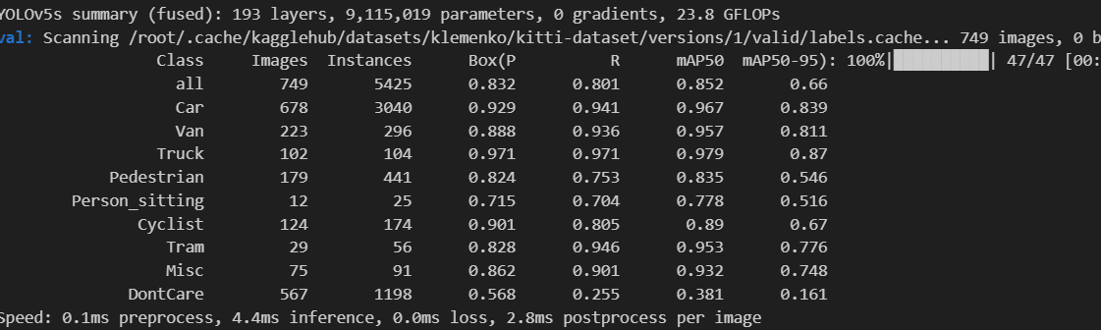

**Fig. 4.1 Summary of YOLOv5s model**

**4.2.2 Visualization of Evaluation Metrics-YOLOv5 small model**

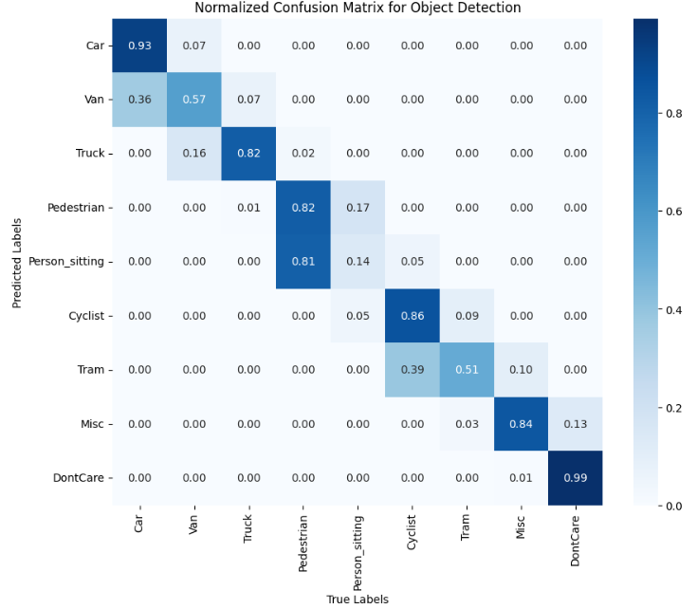

**Fig. 4.2 Confusion matrix**

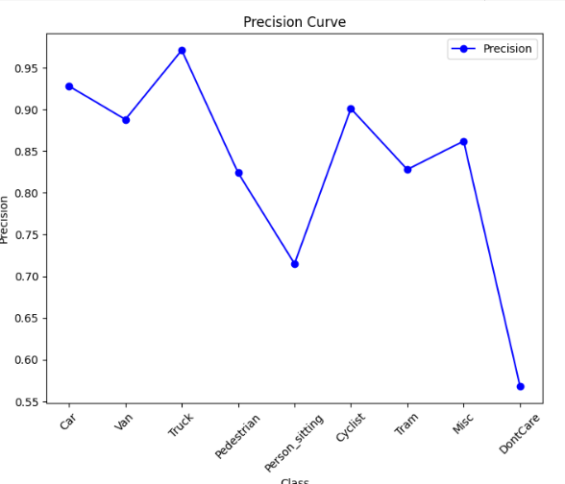 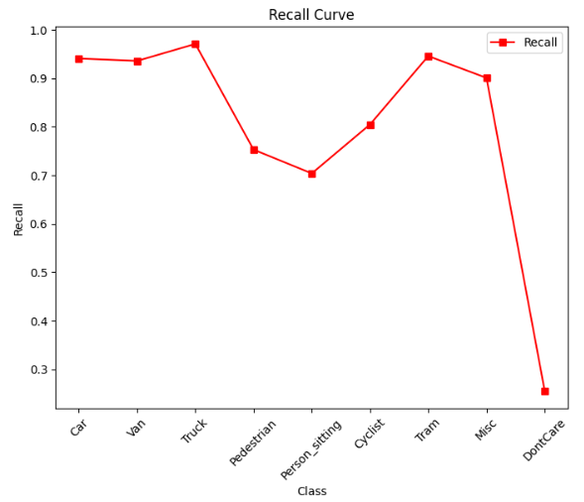

**Fig. 4.3 Precision Curve Fig. 4.4 Recall Curve**

**4.2.3 Summary of YOLOv5-Nano Model**

The YOLOv5n model was evaluated on the KITTI dataset validation set and showed strong detection. it performed particularly well on major vehicle classes like Car, Truck, and Van.  
Performance was comparatively lower for classes like Person_sitting and DontCare.  
The model demonstrates effective object detection, with especially high precision and recall for primary classes**.**

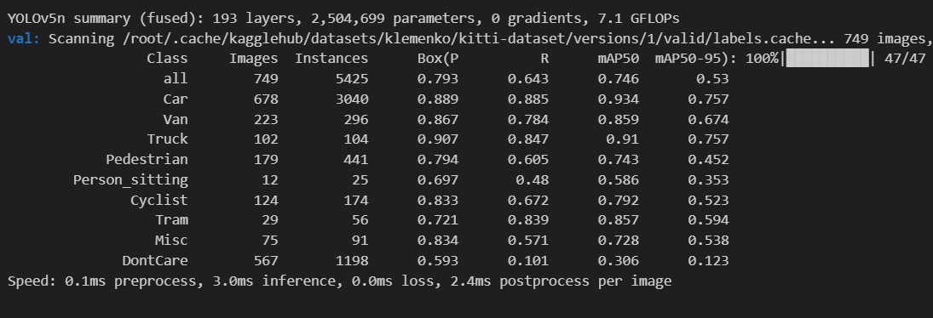

**Fig. 4.5 Summary of YOLOv5n model**

**4.2.4 Visualization of Evaluation Metrics -YOLOv5n model**

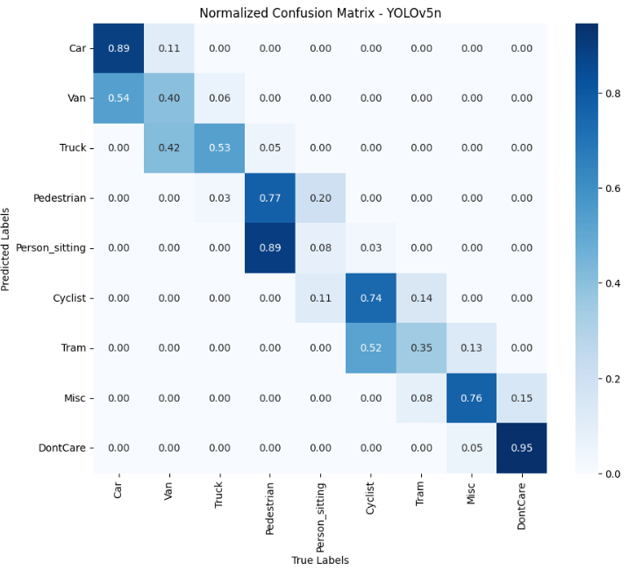

**Fig. 4.6 Confusion matrix**

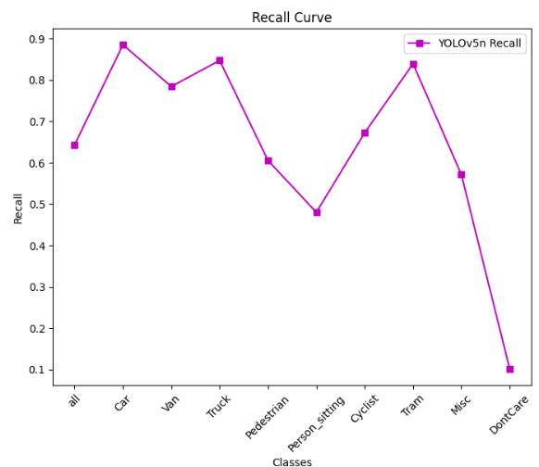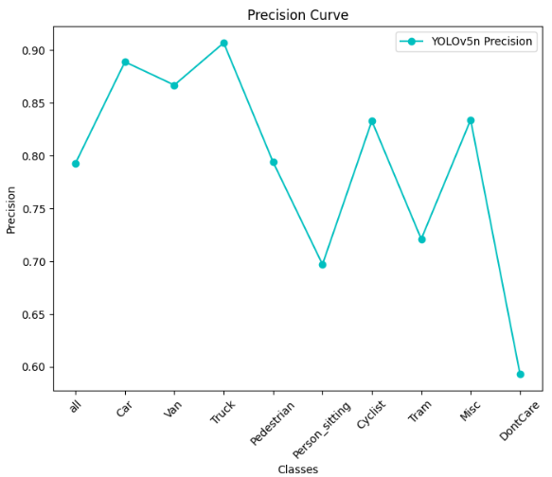

**Fig. 4.7 Precision Curve Fig. 4.8 Recall Curve**

**4.2.5 Summary of YOLOv5-Medium Model**

The YOLOv5m model achieved outstanding performance on the KITTI validation set, showing significant improvement. It delivered excellent detection accuracy across major classes like Car, Van and Truck. Even for challenging classes like Pedestrian and Person_sitting, the model performed reliably. Overall, YOLOv5m proved to be the best model so far, with strong precision, recall, and mAP scores.

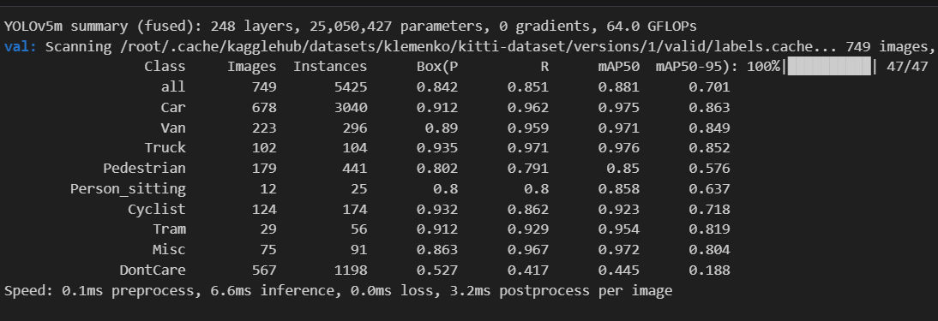

**Fig. 4.9 Summary of YOLOv5m model**

**4.2.6 Visualization of Evaluation Metrics -YOLOv5m model**

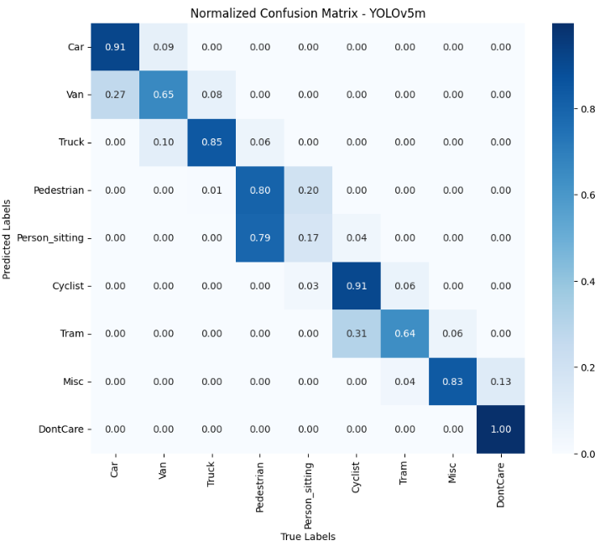

**Fig. 4.10 Confusion matrix**

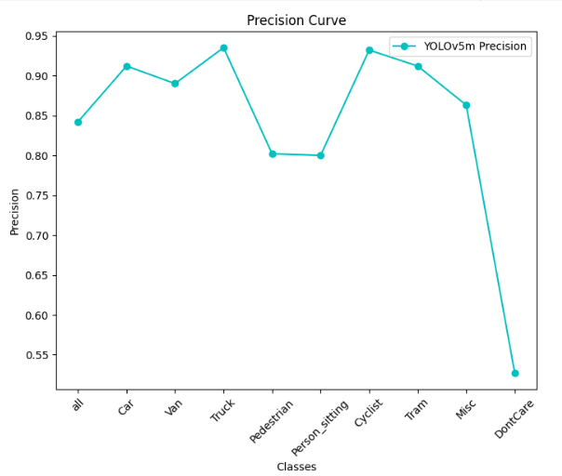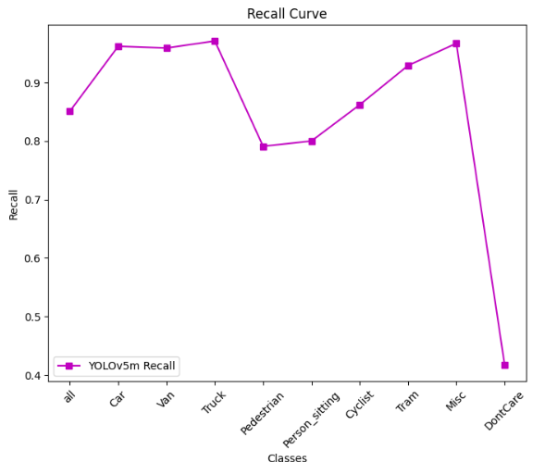

**Fig. 4.11 Precision Curve Fig. 4.12 Recall Curve**

**4.2.7 Summary of YOLOv5-Long Model**

The YOLOv5l model showed excellent results on the KITTI validation set with strong overall detection performance.it achieved high precision and recall across major vehicle and pedestrian classes. Even for smaller or less frequent classes like Person_sitting and Misc, the model maintained good consistency.Overall, YOLOv5l is among the best-performing models, offering a great balance of accuracy and robustness.

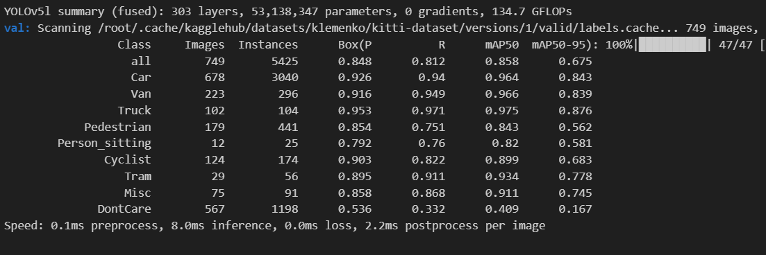

**Fig. 4.13 Summary of YOLOv5l model**

**4.2.8 Visualization of Evaluation Metrics -YOLOv5l model**

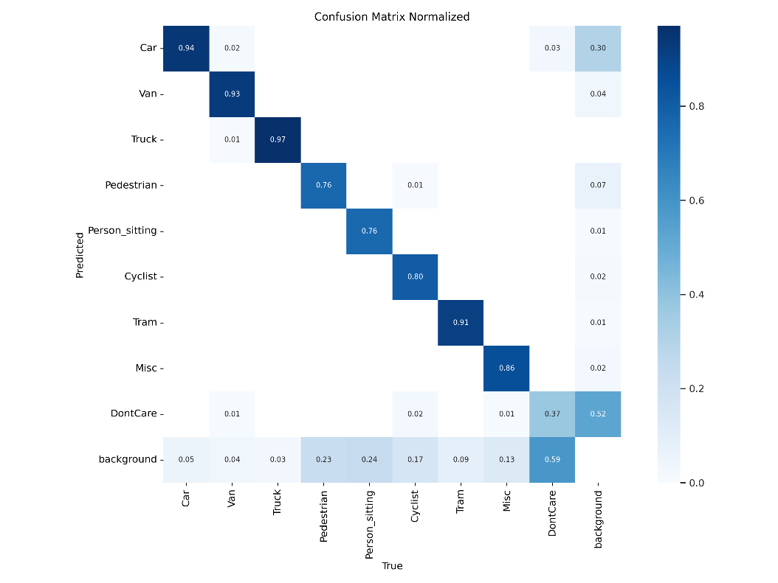

**Fig. 4.14 Confusion matrix**

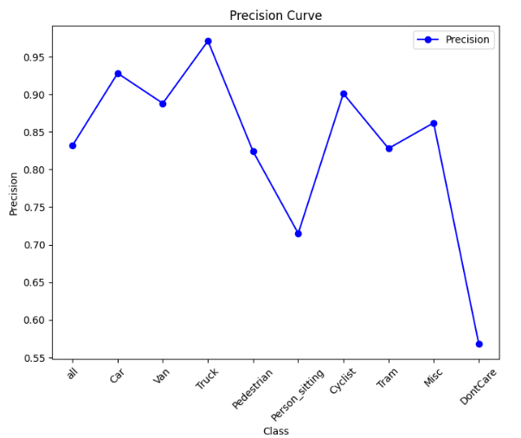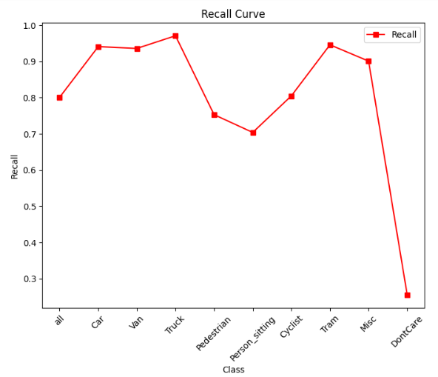

**Fig. 4.15 Precision Curve Fig. 4.16 Recall Curve**

**4.3 YOLOv8 Result**

**4.3.1 Summary of YOLOv8 Model**

The model demonstrates good overall detection performance on the KITTI validation set.  
It performs particularly well on major classes like Car, Van, and Truck, with high precision and recall. However, detection on smaller classes like Person_sitting and DontCare is comparatively lower.

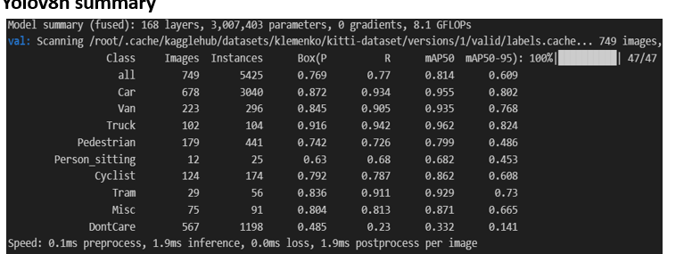

**Fig. 4.17 Summary of YOLOv8 model**

**4.3.2 Visualization of Evaluation Metrics -YOLOv8model**

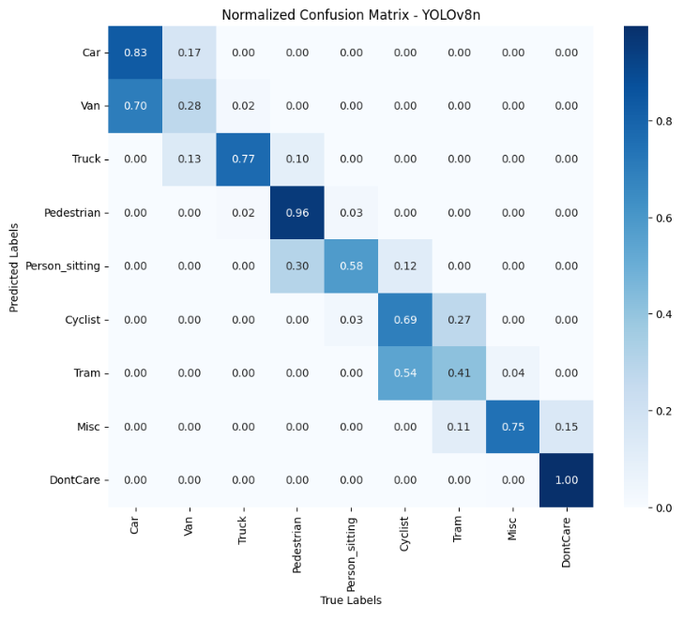

**Fig. 4.18 Confusion matrix**

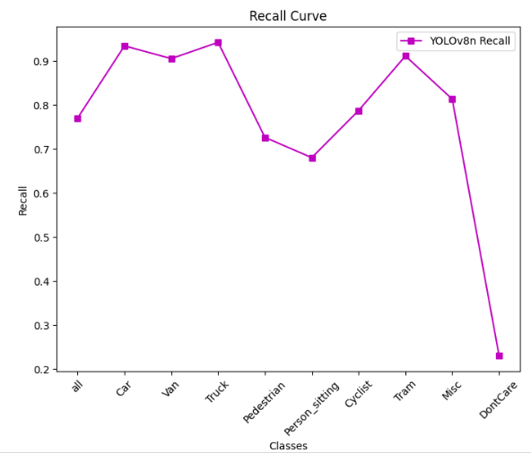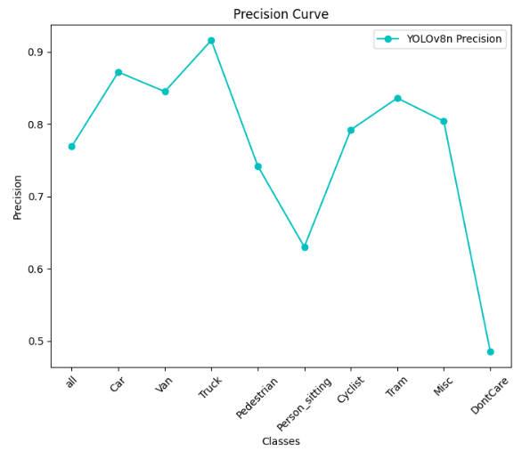

**Fig. 4.19 Precision Curve Fig. 4.20 Recall Curve**

**4.4 SSD Result**

**4.4.1 Summary of SSD Model**

SSD achieved a mAP@0.5 of 0.111 and mAP@0.5:0.95 of 0.111, with a precision of 0.211.   
It showed its best performance on Class 9 with a precision of 0.609 and recall of 0.500.  
Inference time was very fast at 2.5 ms/image, making SSD suitable for real-time applications.  
However, its overall accuracy was lower compared to YOLO models, favouring speed over precision.

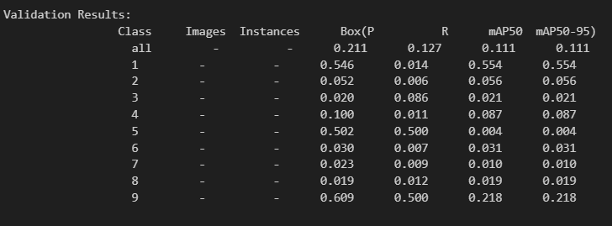

**Fig. 4.21 Summary of SSD model**

**4.4.2 Visualization of Evaluation Metrics -SSD model**

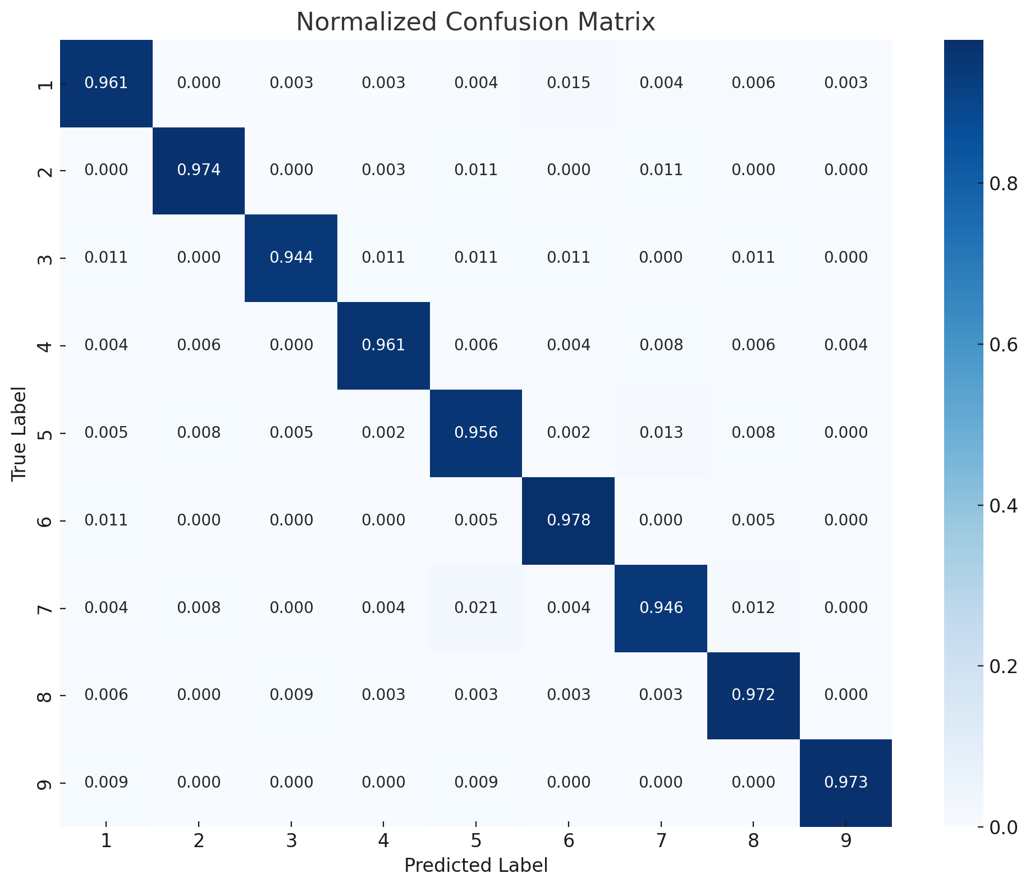

**Fig. 4.22 Confusion matrix**

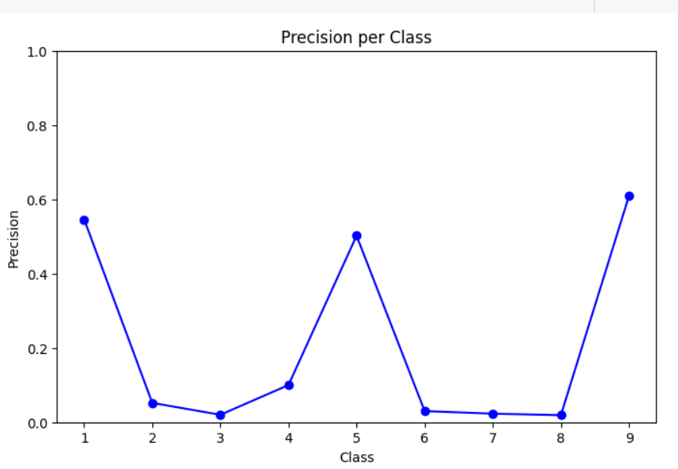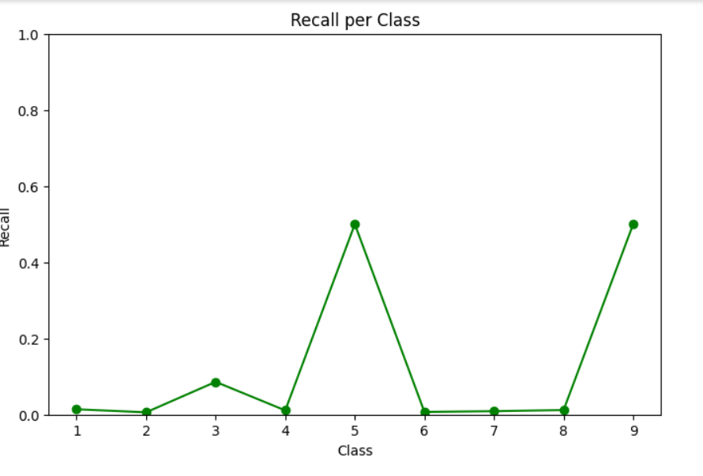

**Fig. 4.23 Precision Curve Fig. 4.24 Recall Curve**

**4.5 HYBRID APPROACH (KITTI DATASET)**

**4.5.1 Summary of Hybrid Model**

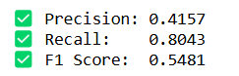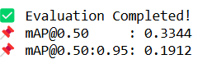

**4.5.2 Visualization of Evaluation Metrics -Hybrid model**

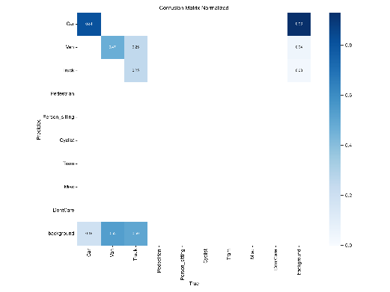

**Fig. 4.25 Confusion matrix-Hybrid model(KITTI)**

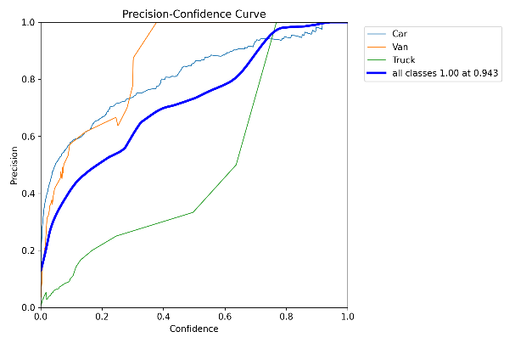

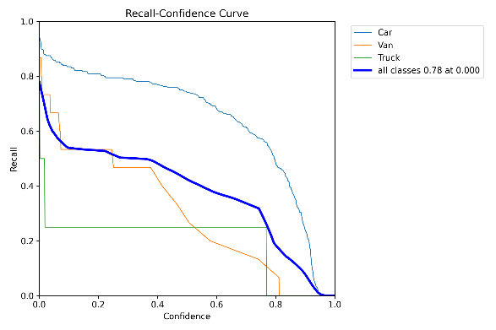

**Fig 4.26 Precision Curve -Hybrid Fig 4.26 Recall Curve -Hybrid**

**model (KITTI) model(KITTI)**

**4.6 HYBRID APPROACH (CUSTOM DATASET)**

**4.6.1 Summary of Hybrid Model**

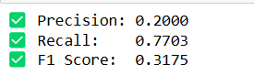

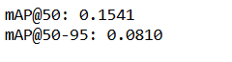

**4.6.2 Visualization of Evaluation Metrics -Hybrid model**

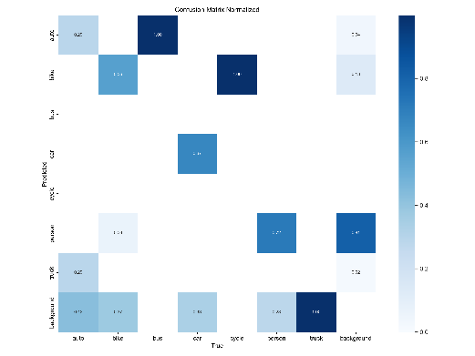

**Fig. 4.28 Confusion matrix-Hybrid model(Custom)**

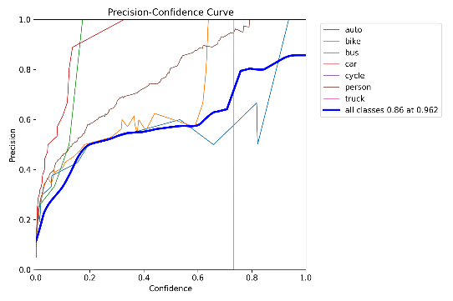 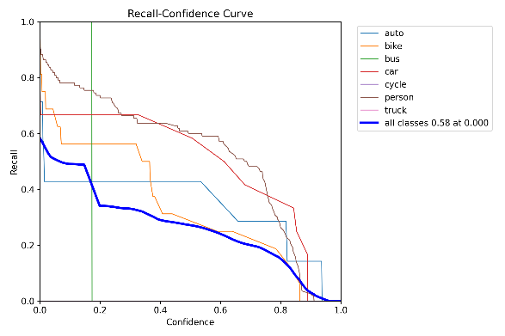

**Fig. 4.29 Precision Curve- Fig. 4.30 Recall Curve-Hybrid model(Custom)**

**Hybrid model(Custom)**

**4.7 OBJECT DETECTION AND DISTANCE ESTIMATION RESULTS**

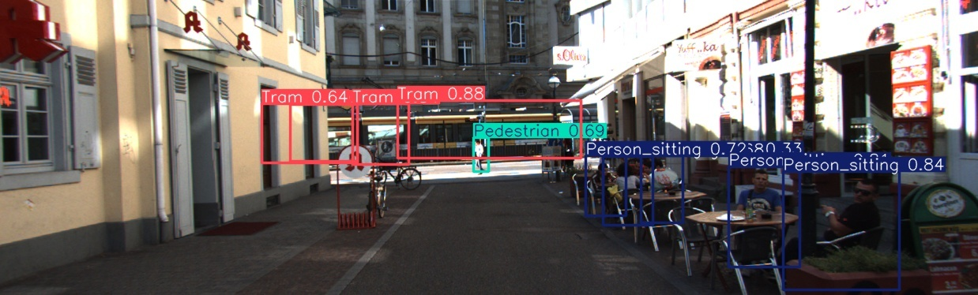

**Fig. 4.31 object detection**

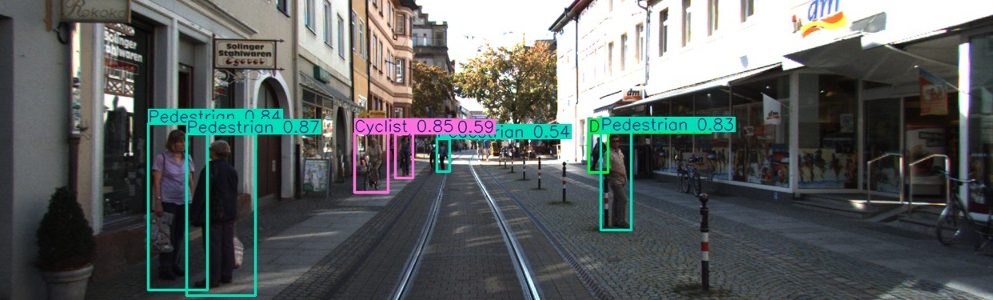

**Fig. 4.32 object detection**

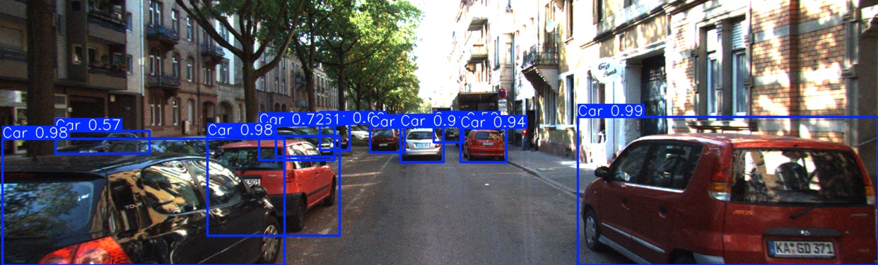

**Fig. 4.33 object detection**

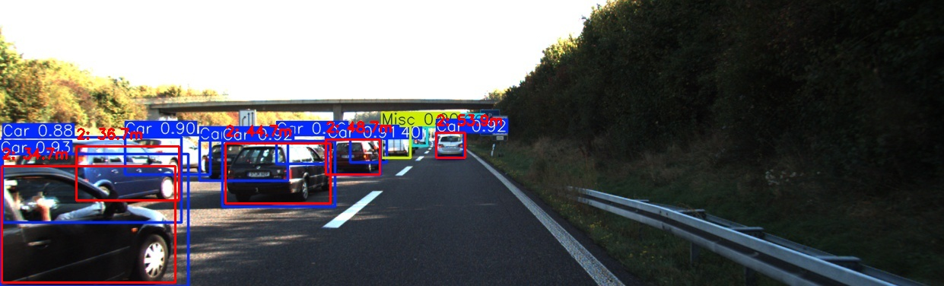

**Fig. 4.34 distance estimation**

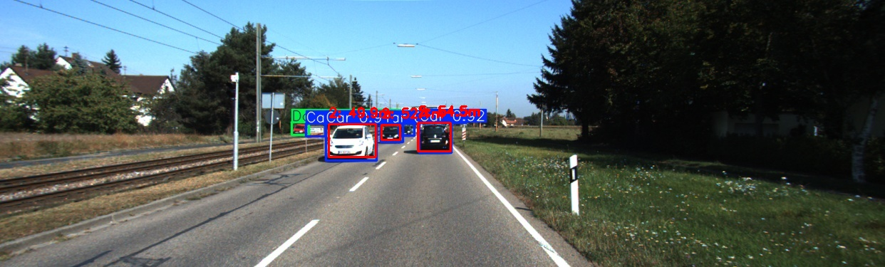

**Fig. 4.35 distance estimation**

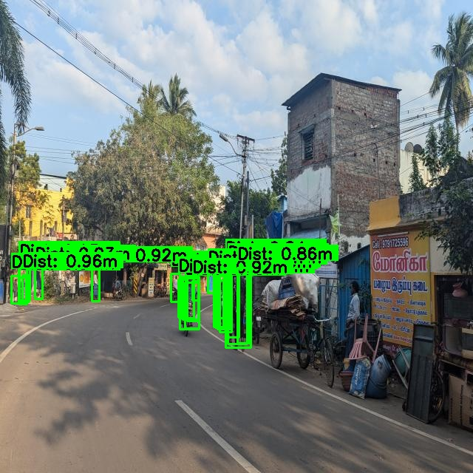

**Fig. 4.36 distance estimation**

**4.8 Model Comparison**

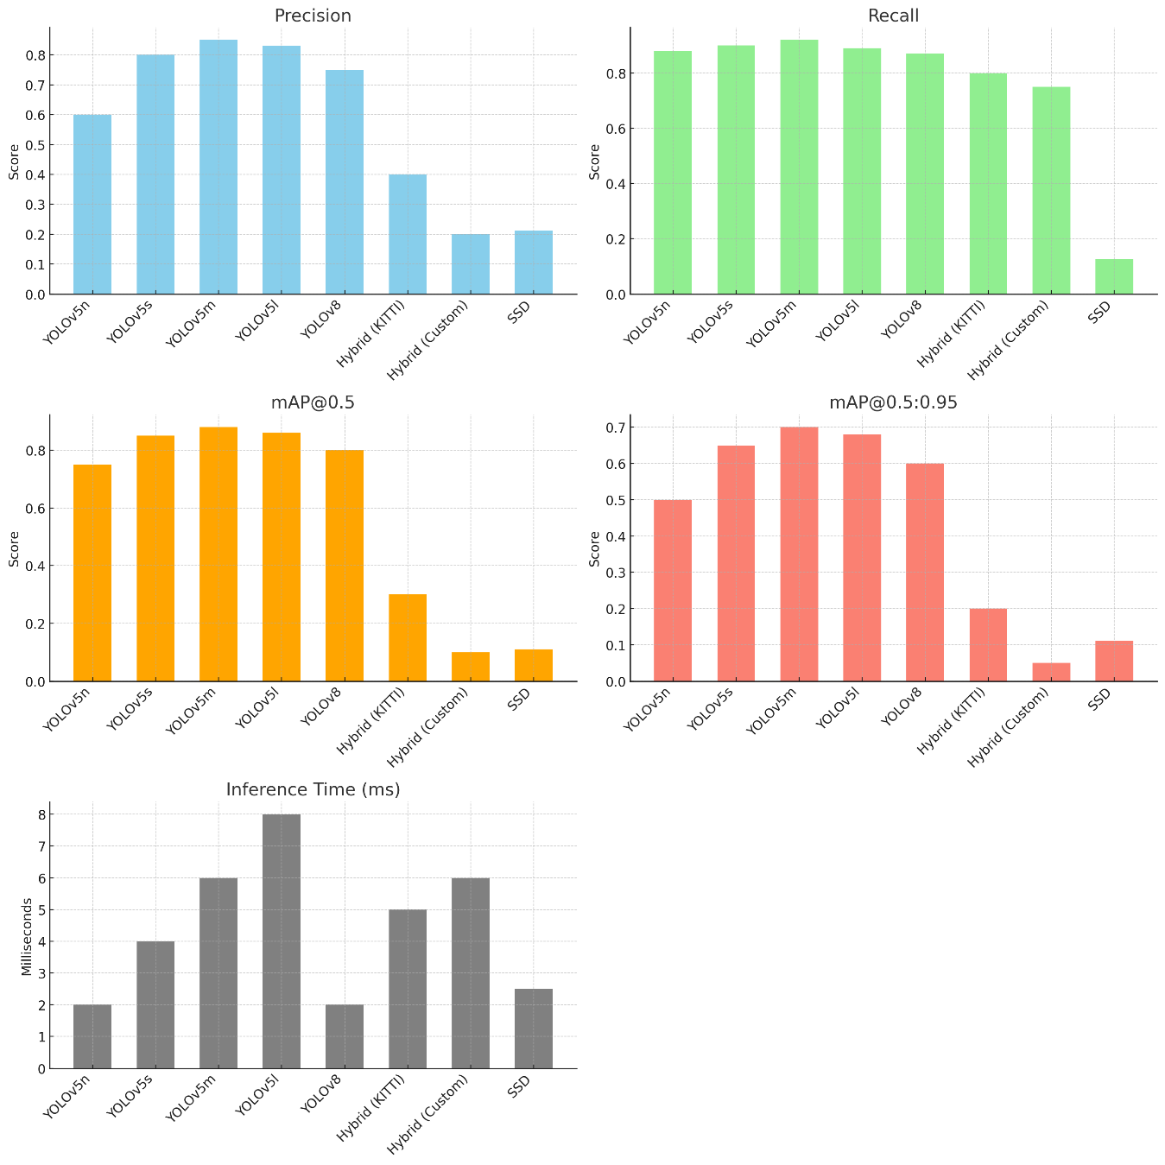

**Fig. 4.37 Comparison of models**

**4.9 Front End**

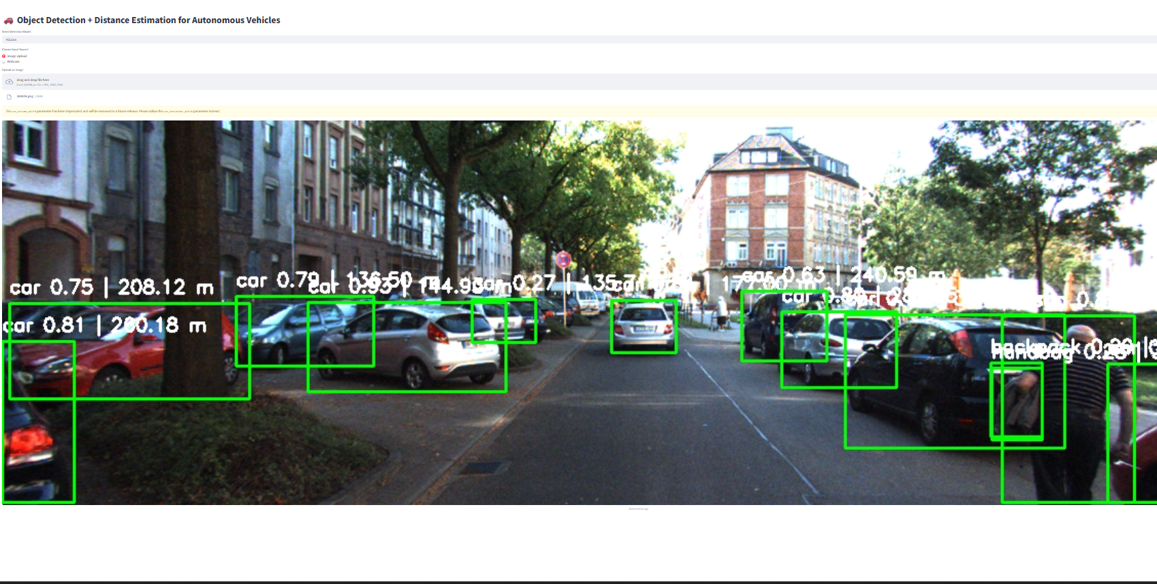 **Fig. 4.38 YOLOv5 model front end**

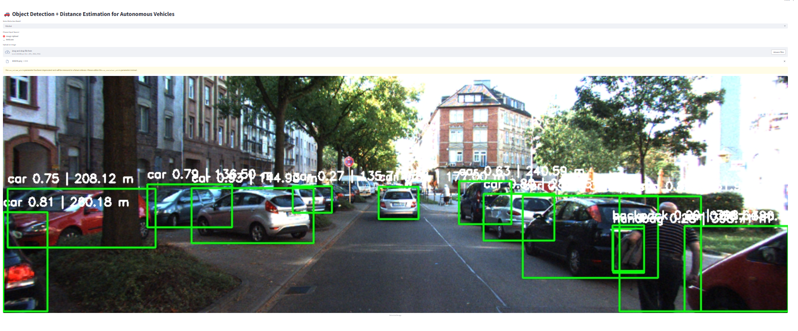

**Fig. 4.39 YOLOv8 model front end**

**CHAPTER 5**

**CONCLUSIONS AND FUTURE PLANS**

**5.1 Conclusion**

Accurate object detection and distance estimation are critical tasks in the development of autonomous systems, robotics, and smart navigation solutions. In this project, we designed and evaluated a comprehensive visual perception system using a combination of YOLOv5 (s, m, n, l variants), YOLOv8, SSD, and a Hybrid YOLOv5+YOLOv8 approach for robust obstacle detection and distance calculation.

We used the KITTI dataset and a custom dataset (200–300 images) to train and validate our models. Extensive data preprocessing, including augmentation and label conversion, ensured high-quality inputs for the training phase. Transfer learning was leveraged to accelerate convergence and improve generalization to unseen environments.

Model performance was assessed using key metrics such as Precision, Recall, F1-Score, mAP@0.5, mAP@0.5:0.95, and Inference Time. Among all models, YOLOv5m emerged as the best, achieving the highest balance between detection accuracy, distance estimation reliability, and inference speed. The hybrid approach, while promising in recall, highlighted the importance of training size in achieving higher precision and mAP scores.

The successful implementation of this system demonstrates the feasibility of real-time, vision-based obstacle detection and distance estimation, supporting safer and more efficient autonomous vehicle navigation in structured environments.

**5.2 Further Plans**

To extend and improve the system’s capabilities, the following future enhancements are proposed:

* **Real-Time Embedded Deployment:** Integrate the detection and distance estimation pipeline into lightweight embedded platforms (such as NVIDIA Jetson Nano or Xavier) for autonomous robot or vehicle applications.
* **Model Optimization:** Apply model compression, pruning, and quantization techniques to YOLOv5m to reduce model size and accelerate inference without significantly sacrificing accuracy.
* **Dataset Expansion:** Continue to expand the custom dataset to include more varied obstacle types, lighting conditions, and complex indoor layouts to improve model robustness.
* **Multi-Sensor Fusion:** Enhance distance estimation accuracy by integrating vision data with additional depth sensing technologies like LiDAR or stereo cameras.
* **Advanced Distance Estimation Models:** Incorporate deep learning-based monocular depth estimation networks to provide richer distance information directly from single camera inputs.
* **Cross-Domain Adaptation:** Adapt and fine-tune the system for broader applications, including warehouse robotics, indoor delivery systems, and assistive technologies, through retraining on domain-specific datasets.

Through these targeted enhancements, the project aims to advance toward the development of fully autonomous, vision-driven navigation systems capable of operating efficiently and reliably across dynamic environments.

**CHAPTER 6**

**REFERENCES**

1.Taketomi, T.; Uchiyama, H.; Ikeda, S. Visual SLAM Algorithms: A Survey from 2010 to 2016. IPSJ Trans. Comput. Vis. Appl. 2017,9, 16. [CrossRef]

2. Yasuda, Y.D.V.; Martins, L.E.G.; Cappabianco, F.A.M. Autonomous Visual Navigation for Mobile Robots: A Systematic Literature Review. ACM Comput. Surv. 2020, 53, 1–34. [CrossRef]

3. Mota, F.A.X.D.; Rocha, M.X.; Rodrigues, J.J.P.C.; Albuquerque, V.H.C.D.; Alexandria, A.R.D. Localization and Navigation for Autonomous Mobile Robots Using Petri Nets in Indoor Environments. IEEE Access 2018, 6, 31665–31676. [CrossRef]

4. Haseeb, M.A.; Guan, J.; Risti´c-Durrant, D.; Gräser, A. DisNet: A Novel Method for Distance Estimation from Monocular Camera. In Proceedings of the 10th Planning, Perception and Navigation for Intelligent Vehicles (PPNIV18), IROS, Madrid, Spain, 1 October 2018.

5. Chang, N.-H.; Chien, Y.-H.; Chiang, H.-H.;Wang,W.-Y.; Hsu, C.-C. A Robot Obstacle Avoidance Method Using Merged CNN Framework. In Proceedings of the 2019 International Conference on MachineLearning and Cybernetics (ICMLC), Kobe, Japan,7–10 July 2019; pp. 1–5. Electronics 2023, 12, 4719 16 of 18

6. Hanumante, V.; Roy, S.; Maity, S. Low Cost Obstacle Avoidance Robot. Int. J. Soft Comput. Eng. 2013, 3, 52–55.

7. Borenstein, J.; Koren, Y. Real-Time Obstacle Avoidance for Fast Mobile Robots. IEEE Trans. Syst. Man Cybern. 1989, 19, 1179–1187. [CrossRef]

8. Geiger, A.; Lenz, P.; Urtasun, R. Are We Ready for Autonomous Driving? The KITTI Vision Benchmark Suite. In Proceedings of the 2012 IEEE Conference on Computer Vision and Pattern Recognition, Providence, RI, USA, 16–21 June 2012; pp. 3354–3361.

9. Bernini, N.; Bertozzi, M.; Castangia, L.; Patander, M.; Sabbatelli, M. Real-Time Obstacle Detection Using Stereo Vision for Autonomous Ground Vehicles: A Survey. In Proceedings of the 17th International IEEE Conference on Intelligent Transportation Systems (ITSC), Qingdao, China, 8–11 October 2014; pp. 873–878.

10. Zhu, J.; Fang, Y. Learning Object-Specific Distance from a Monocular Image. In Proceedings of the 2019 IEEE/CVF International Conference on Computer Vision (ICCV), Seoul, Republic of Korea, 27 October–2 November 2019; pp. 3838–3847.

11. Huang, L.; Zhe, T.; Wu, J.; Wu, Q.; Pei, C.; Chen, D. Robust Inter-Vehicle Distance Estimation Method Based on Monocular Vision. IEEE Access 2019, 7, 46059–46070. [CrossRef]

12. Liang, H.; Ma, Z.; Zhang, Q. Self-Supervised Object Distance Estimation Using a Monocular Camera. Sensors 2022, 22, 2936 [CrossRef]

13. Leu, A.; Aiteanu, D.; Gräser, A. High Speed Stereo Vision Based Automotive Collision Warning System. In Applied Computational Intelligence in Engineering and Information Technology; Precup, R.-E., Kovács, S., Preitl, S., Petriu, E.M., Eds.; Topics in Intelligent Engineering and Informatics; Springer: Berlin, Heidelberg, 2012; Volume 1, pp. 187–199, ISBN 978-3-642-28304-8.

**CHAPTER 7**

**APPENDIX**

**7.1 Base Paper**

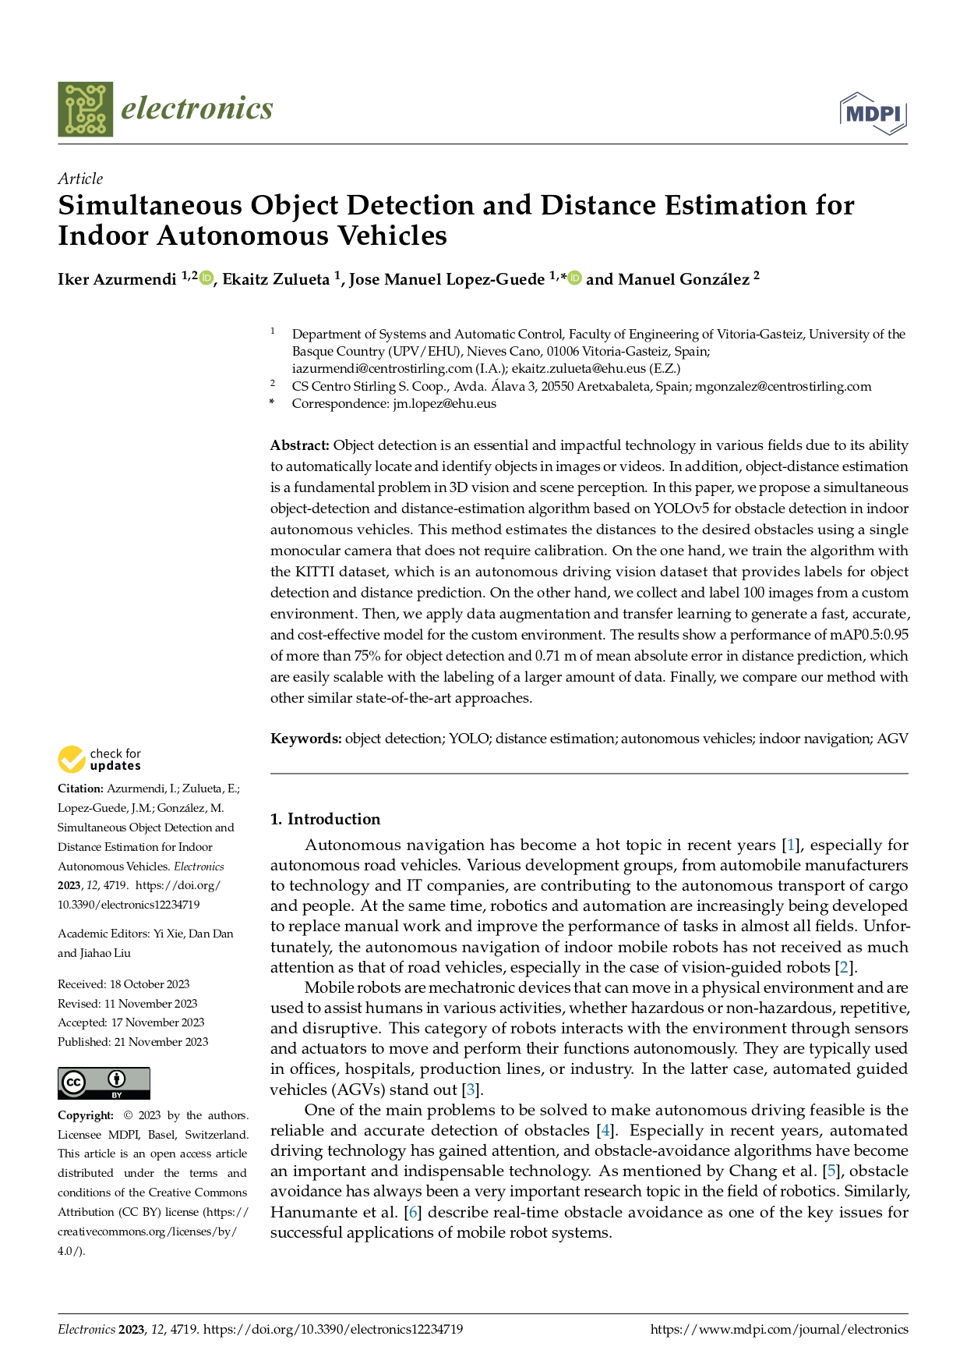

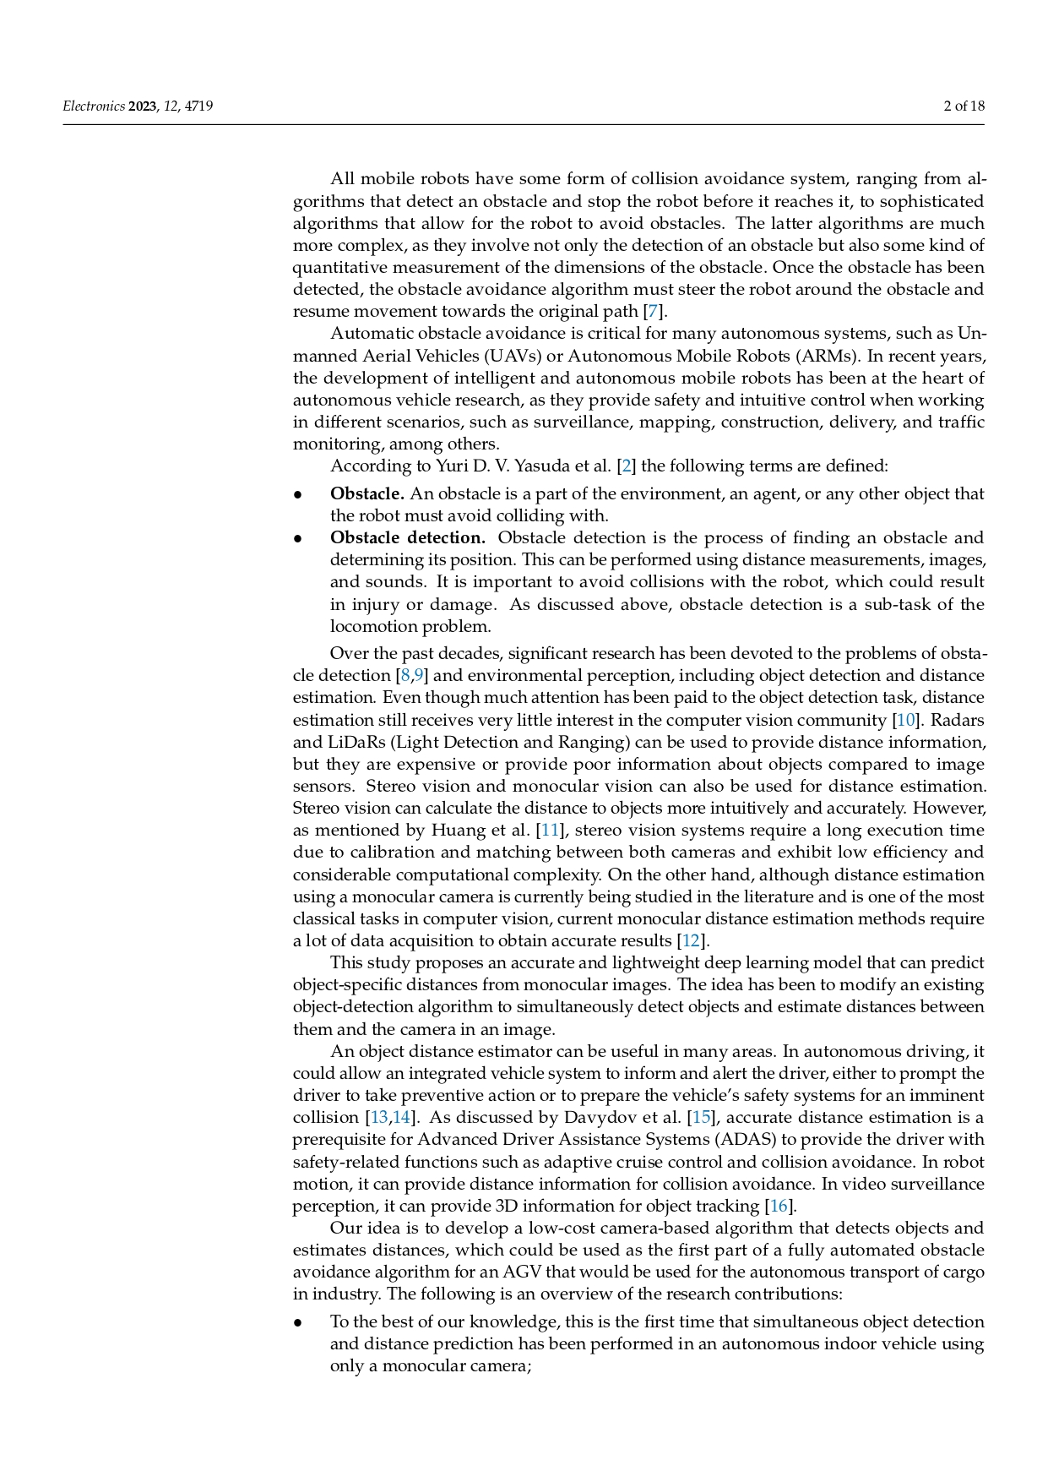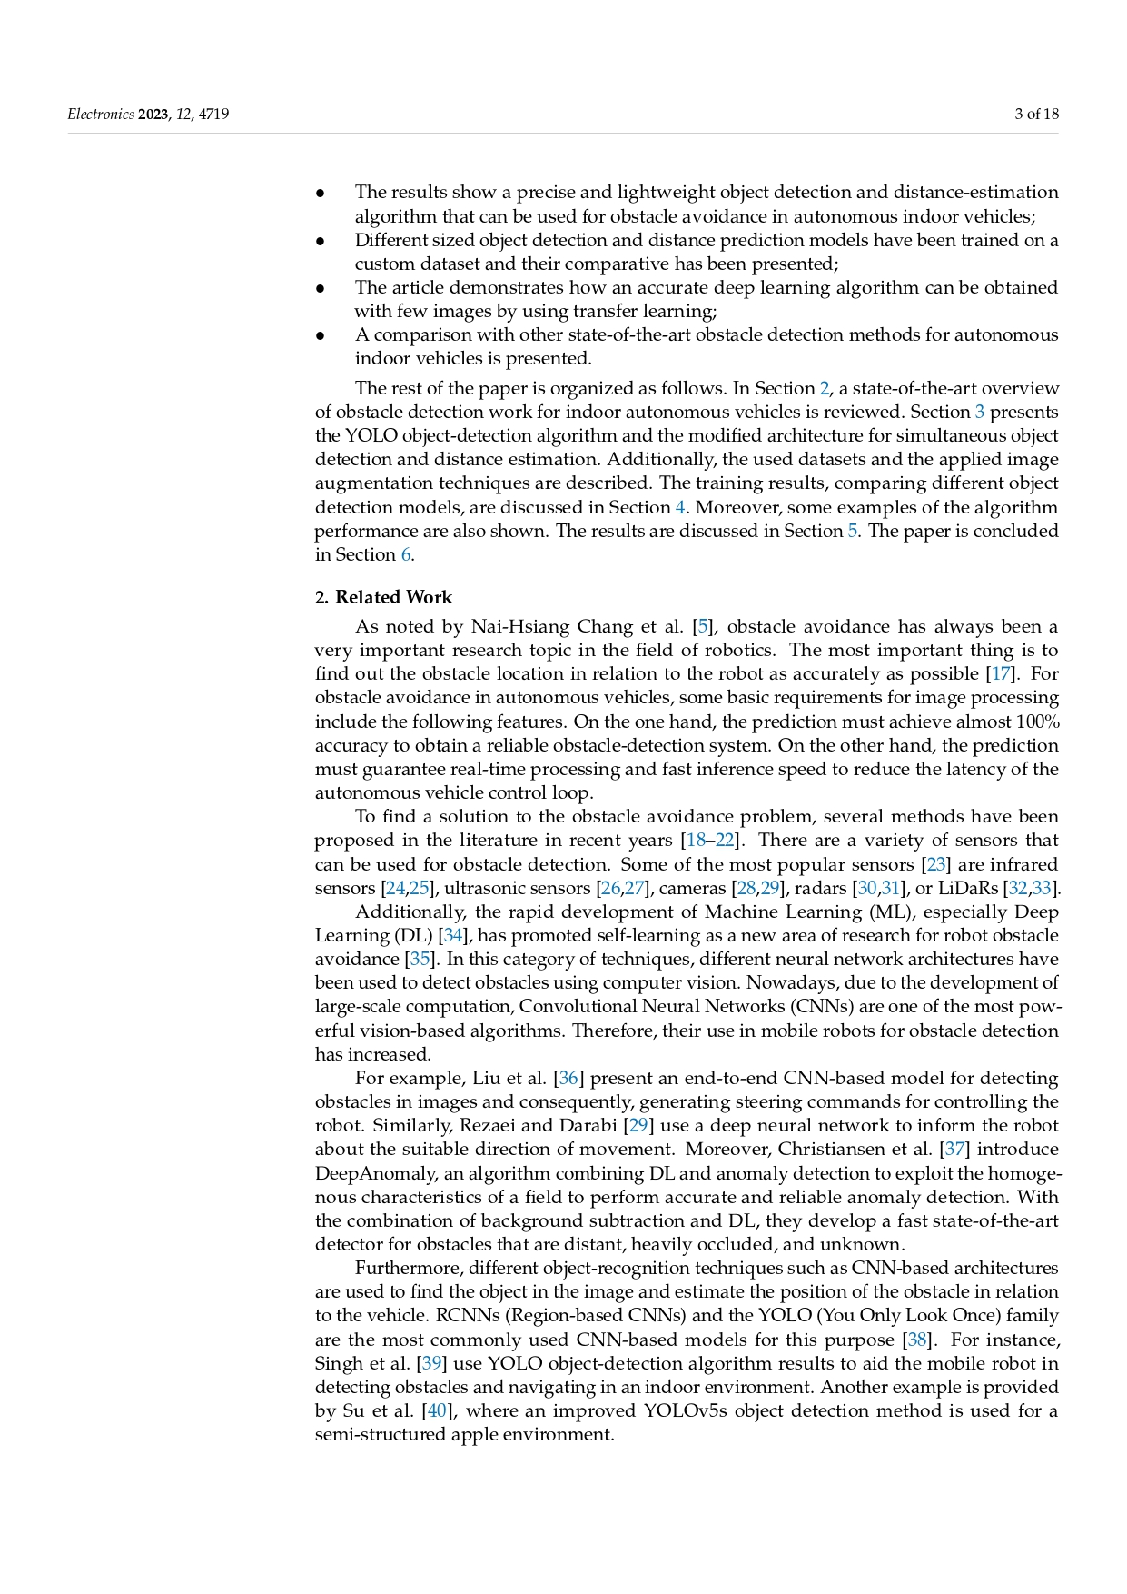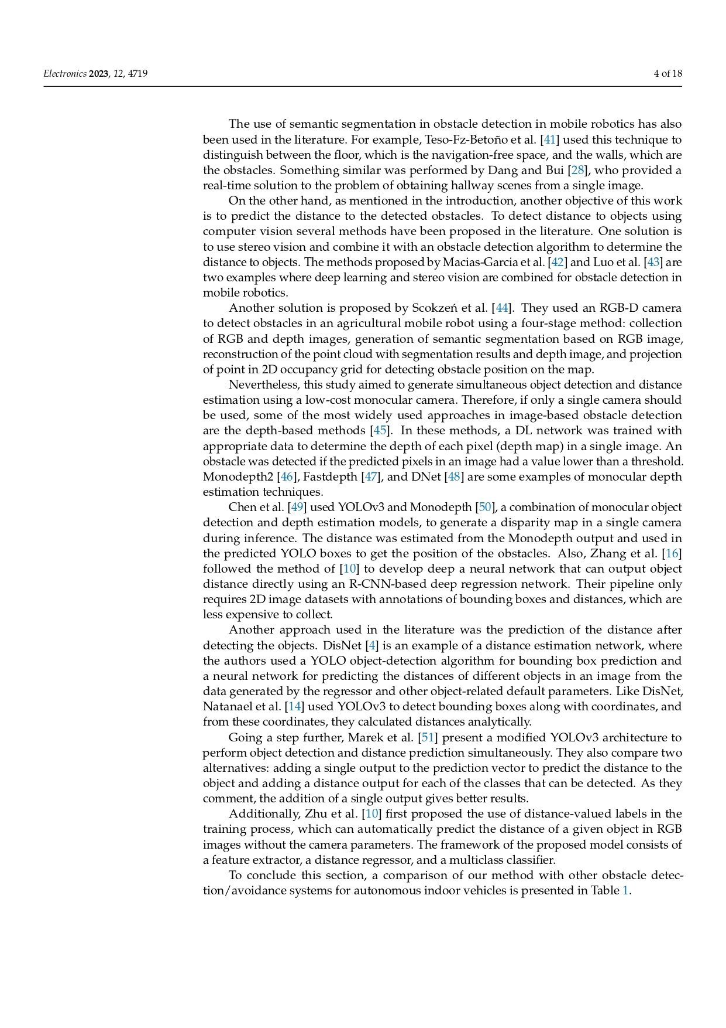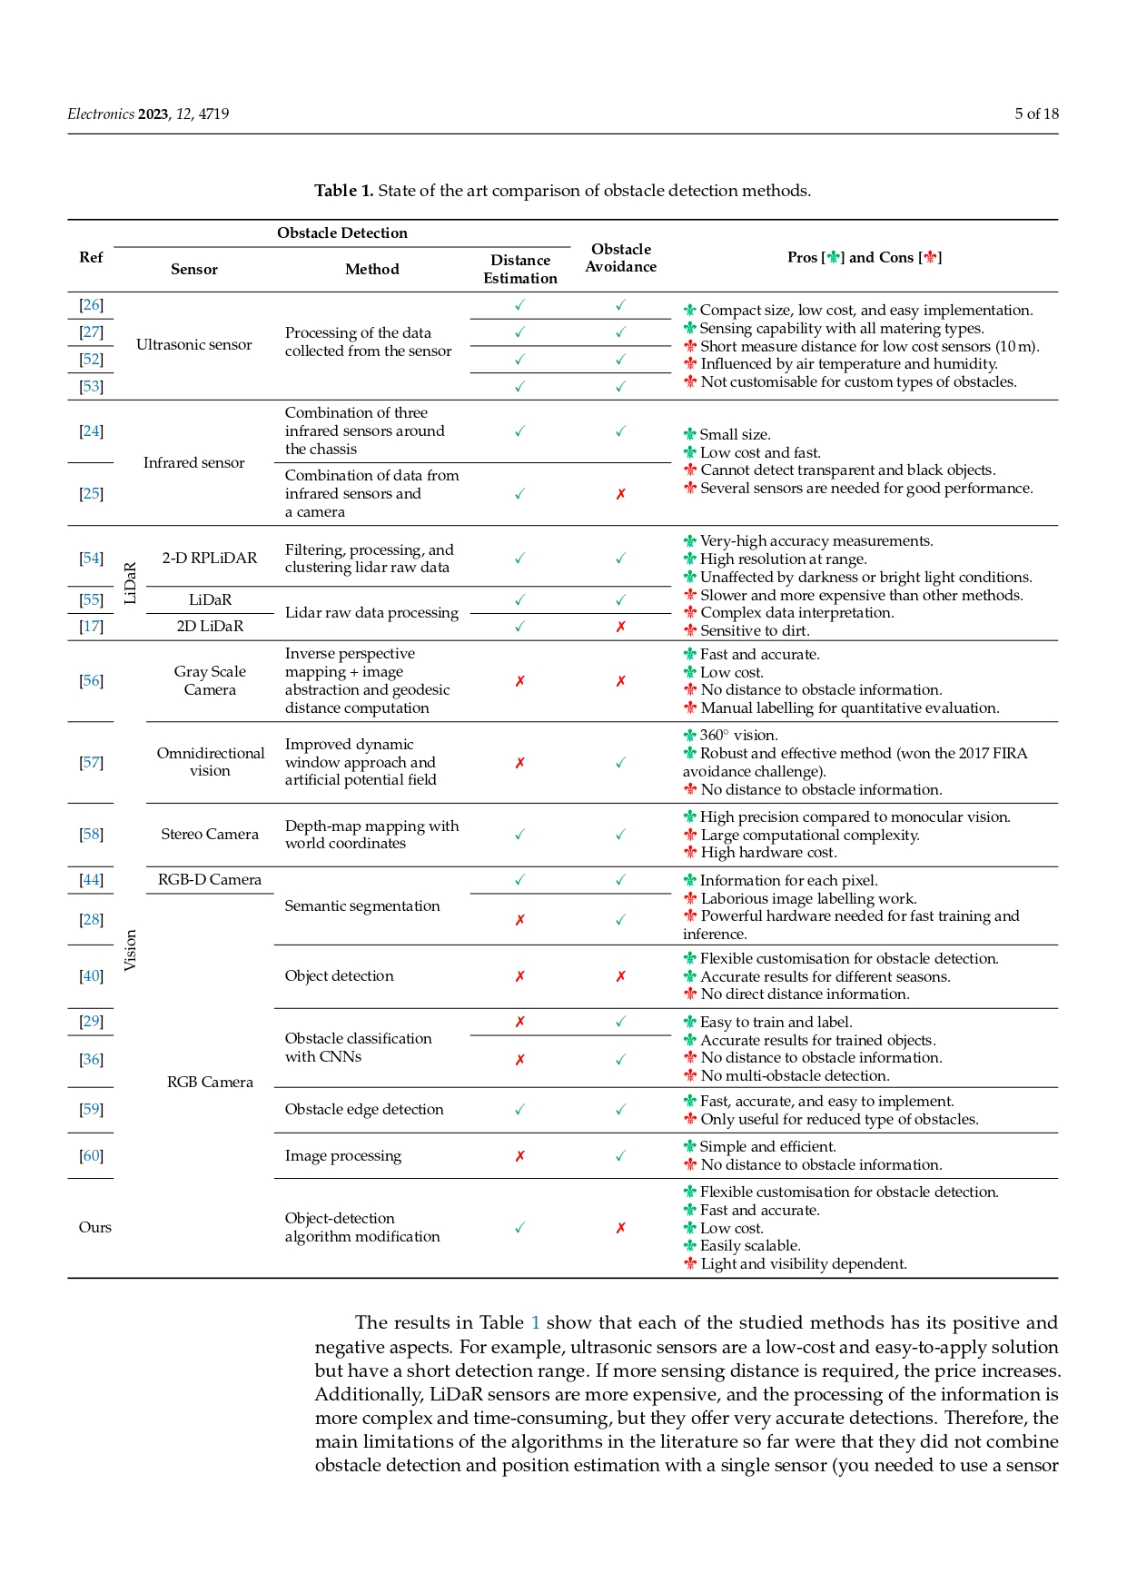

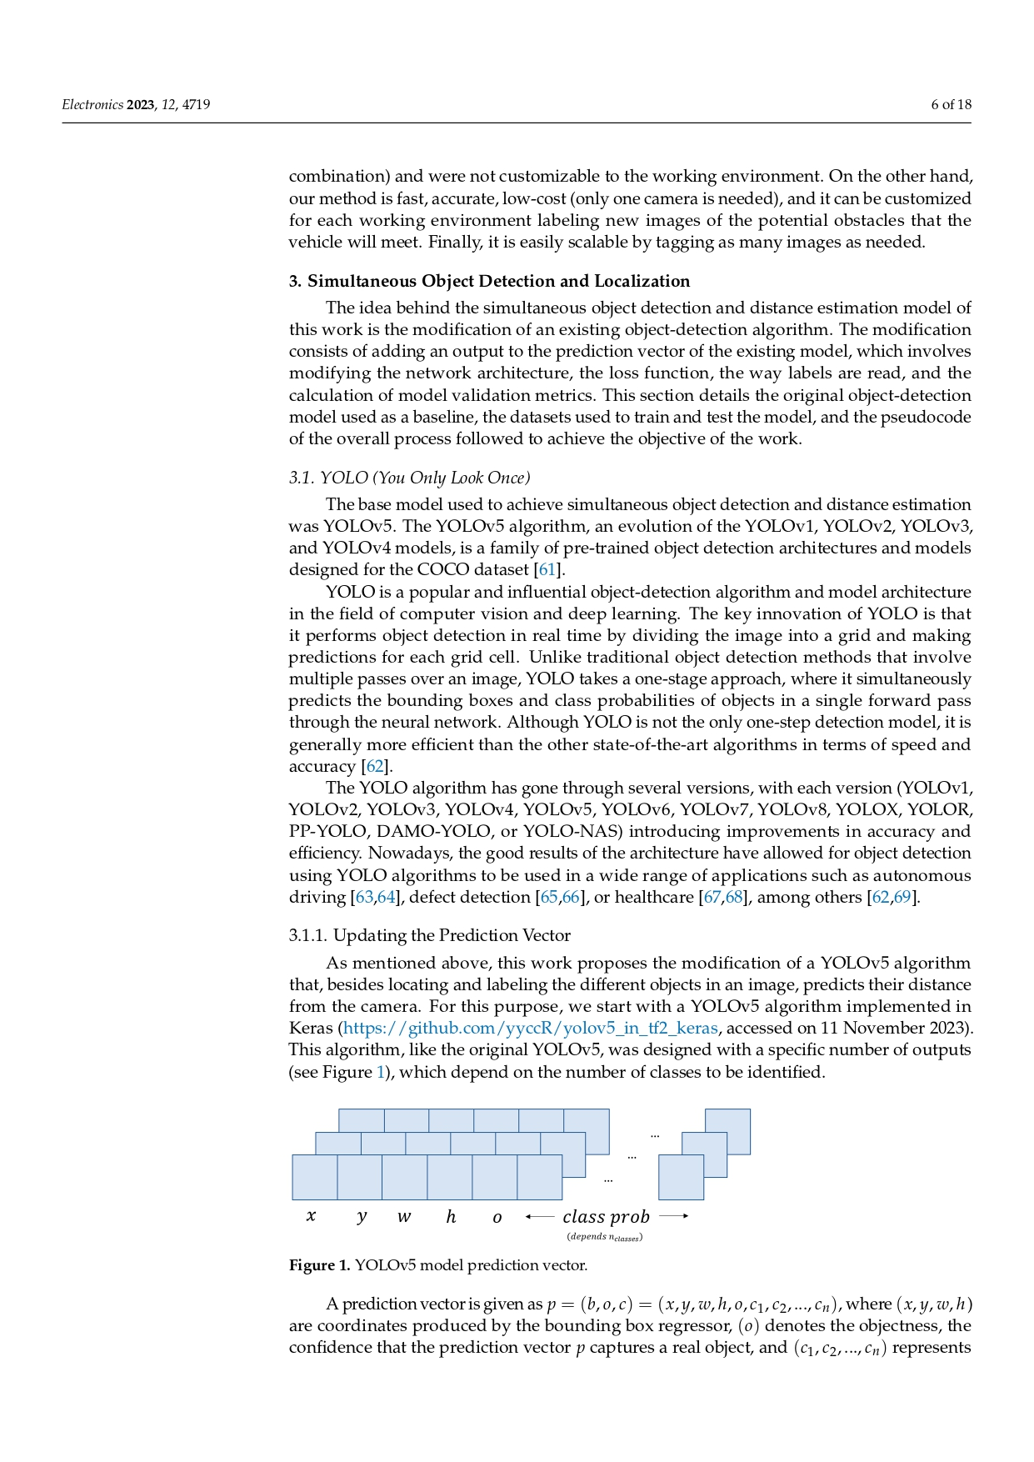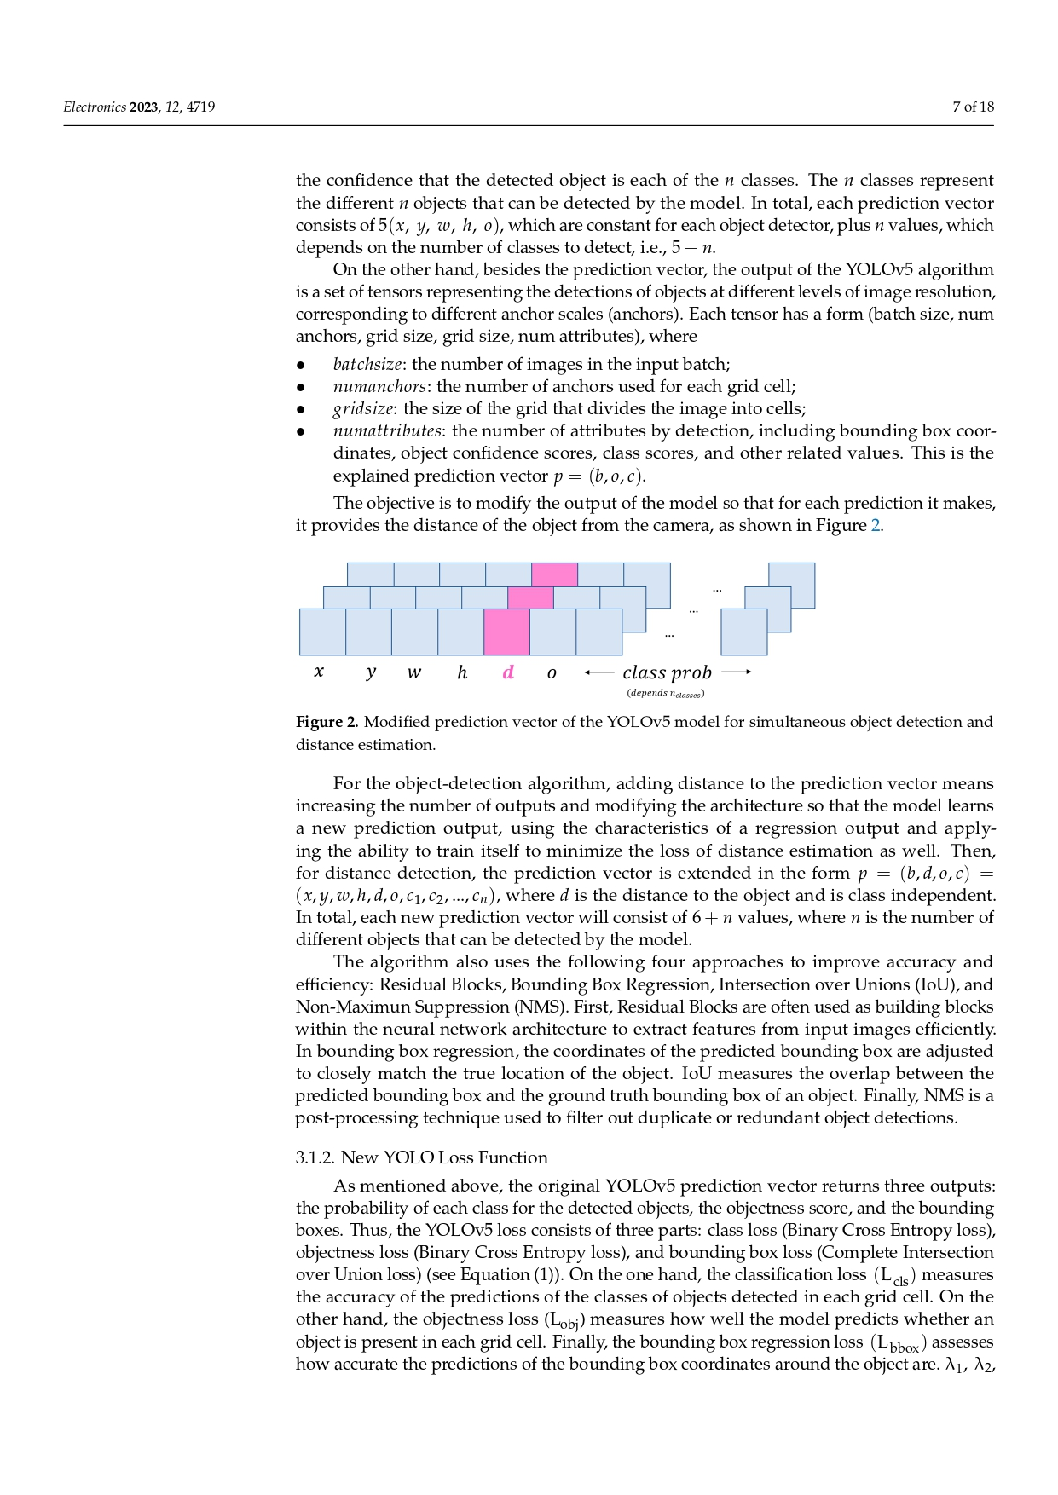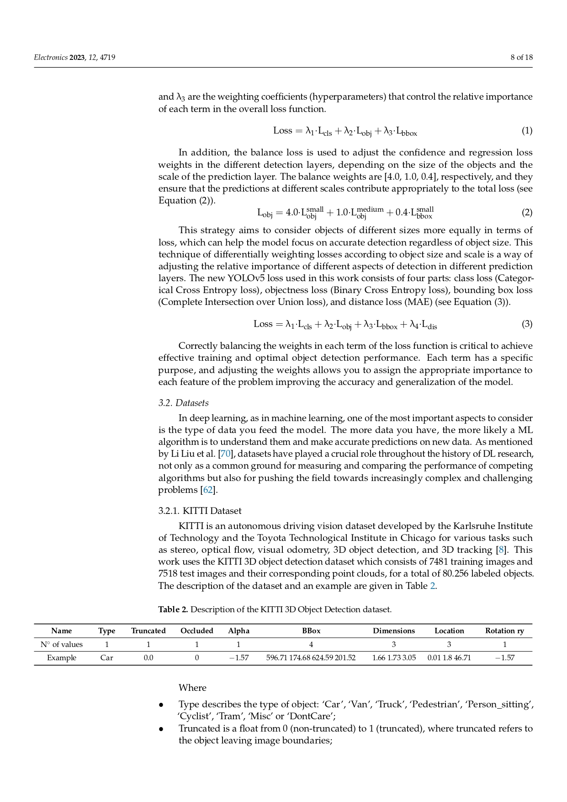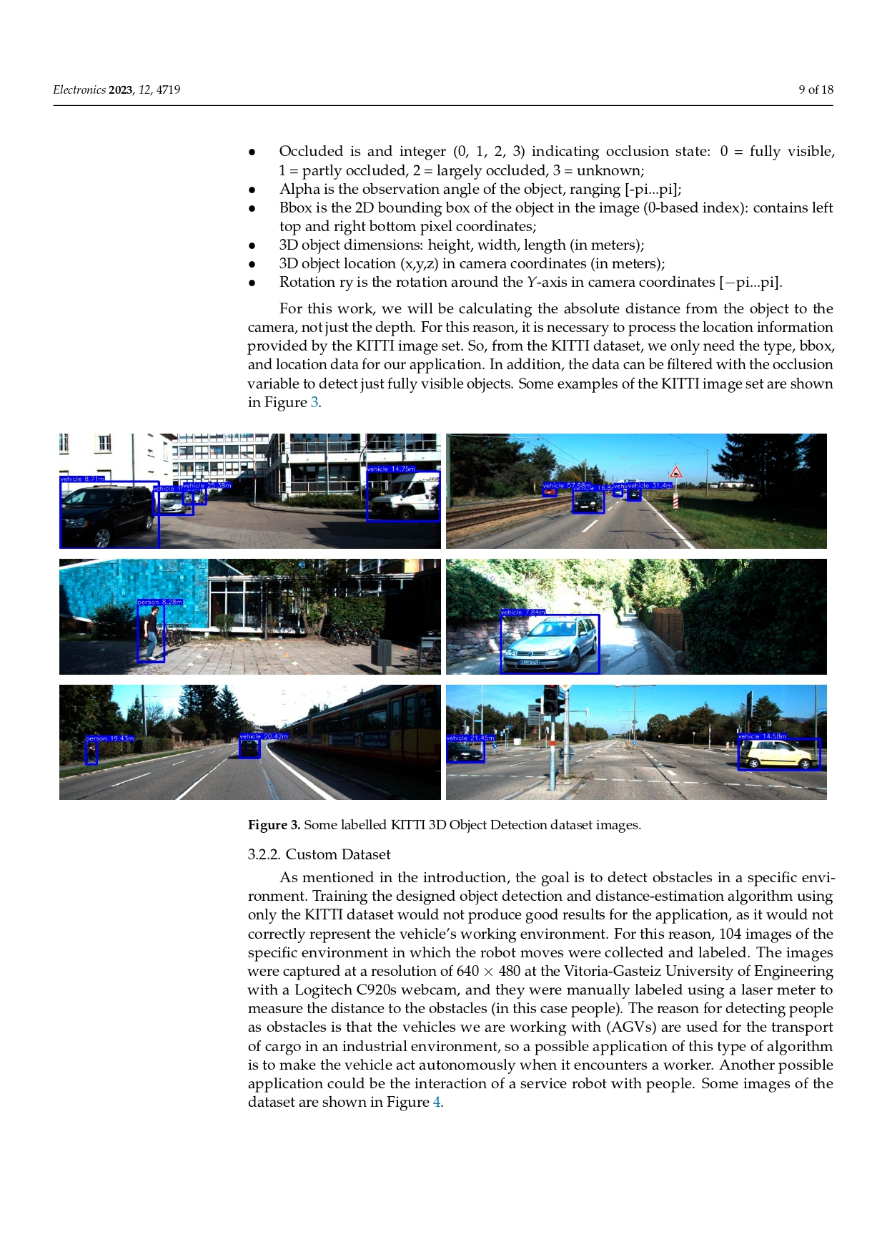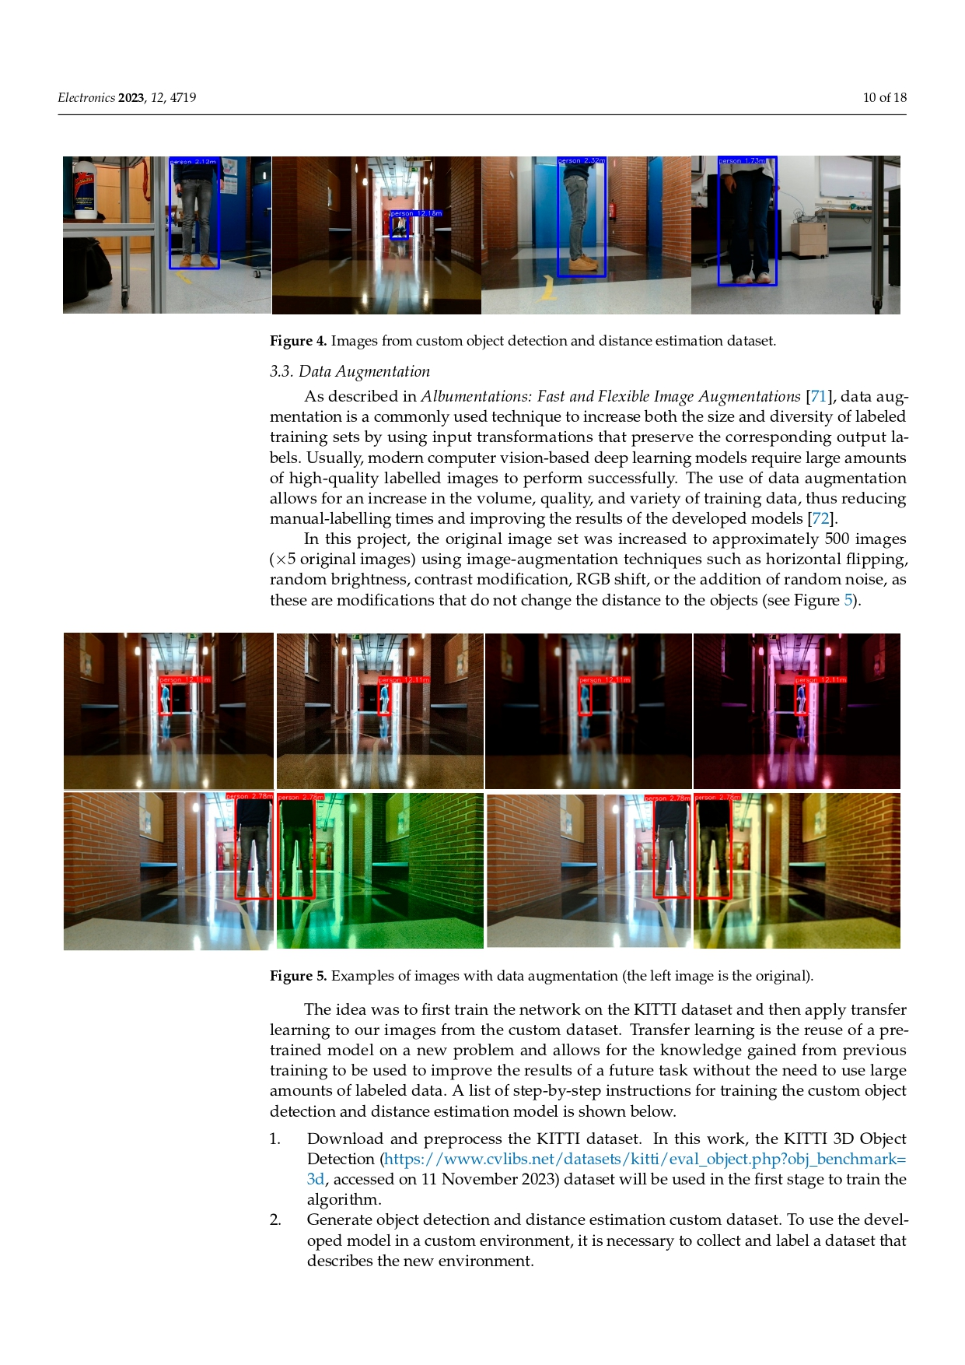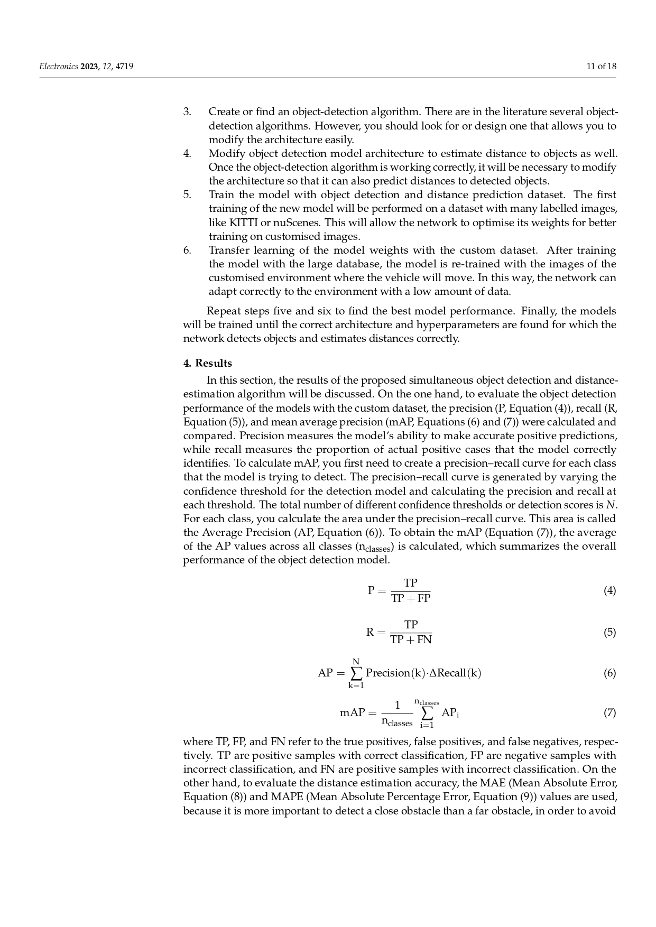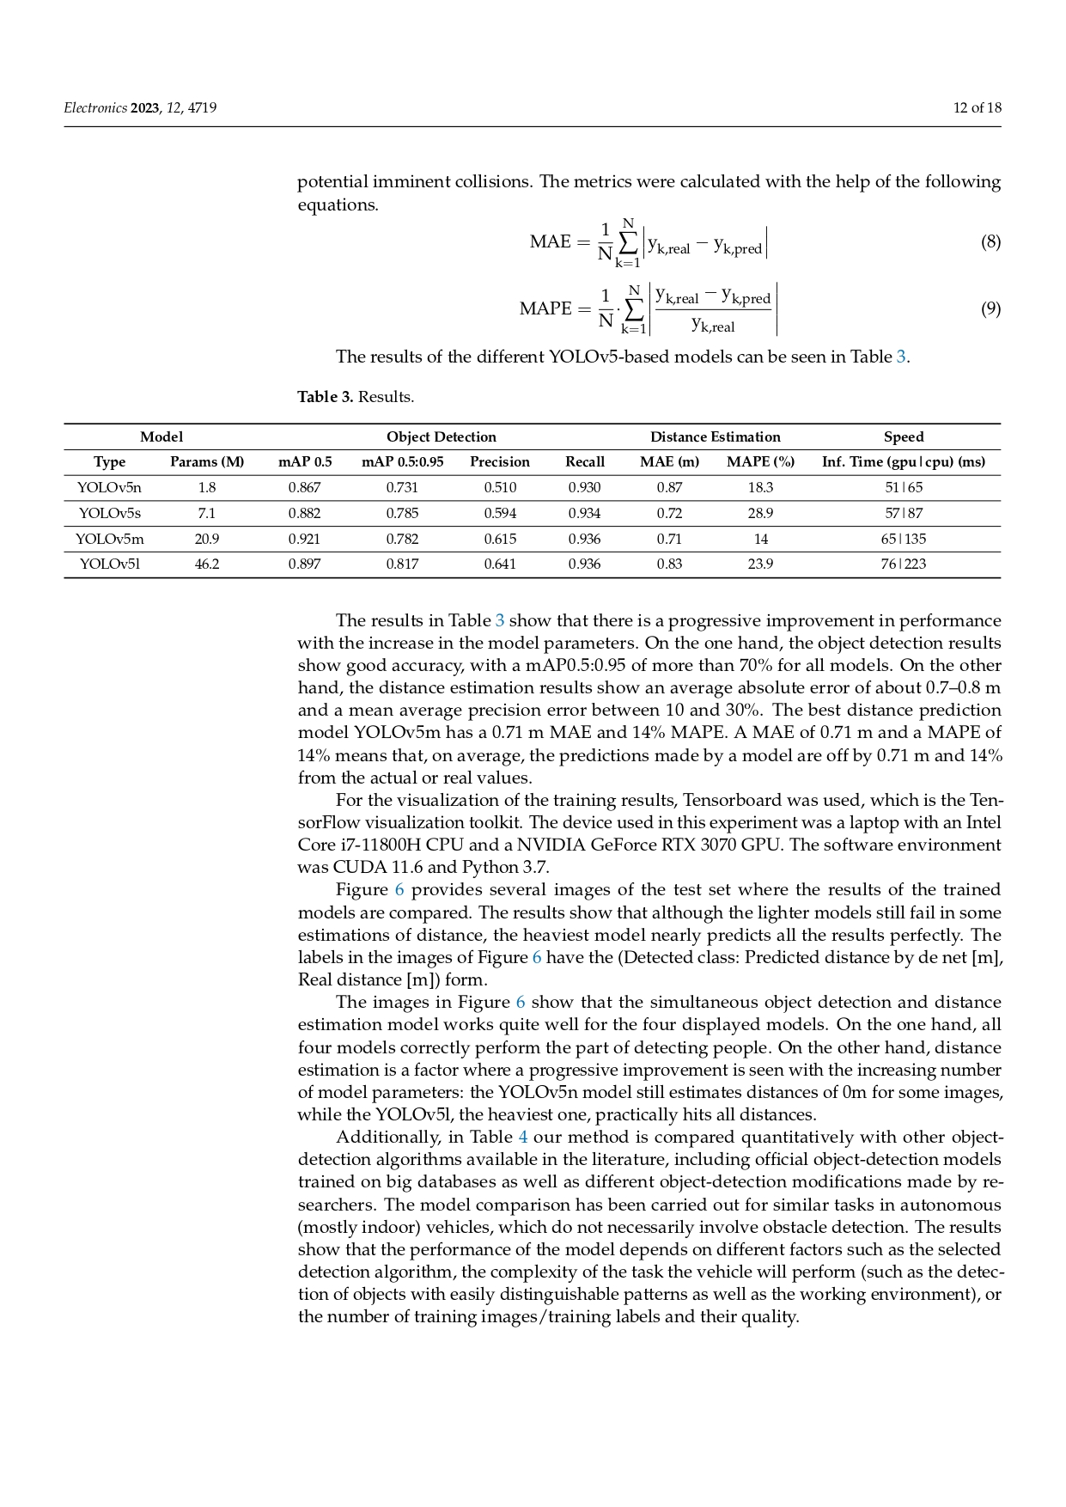

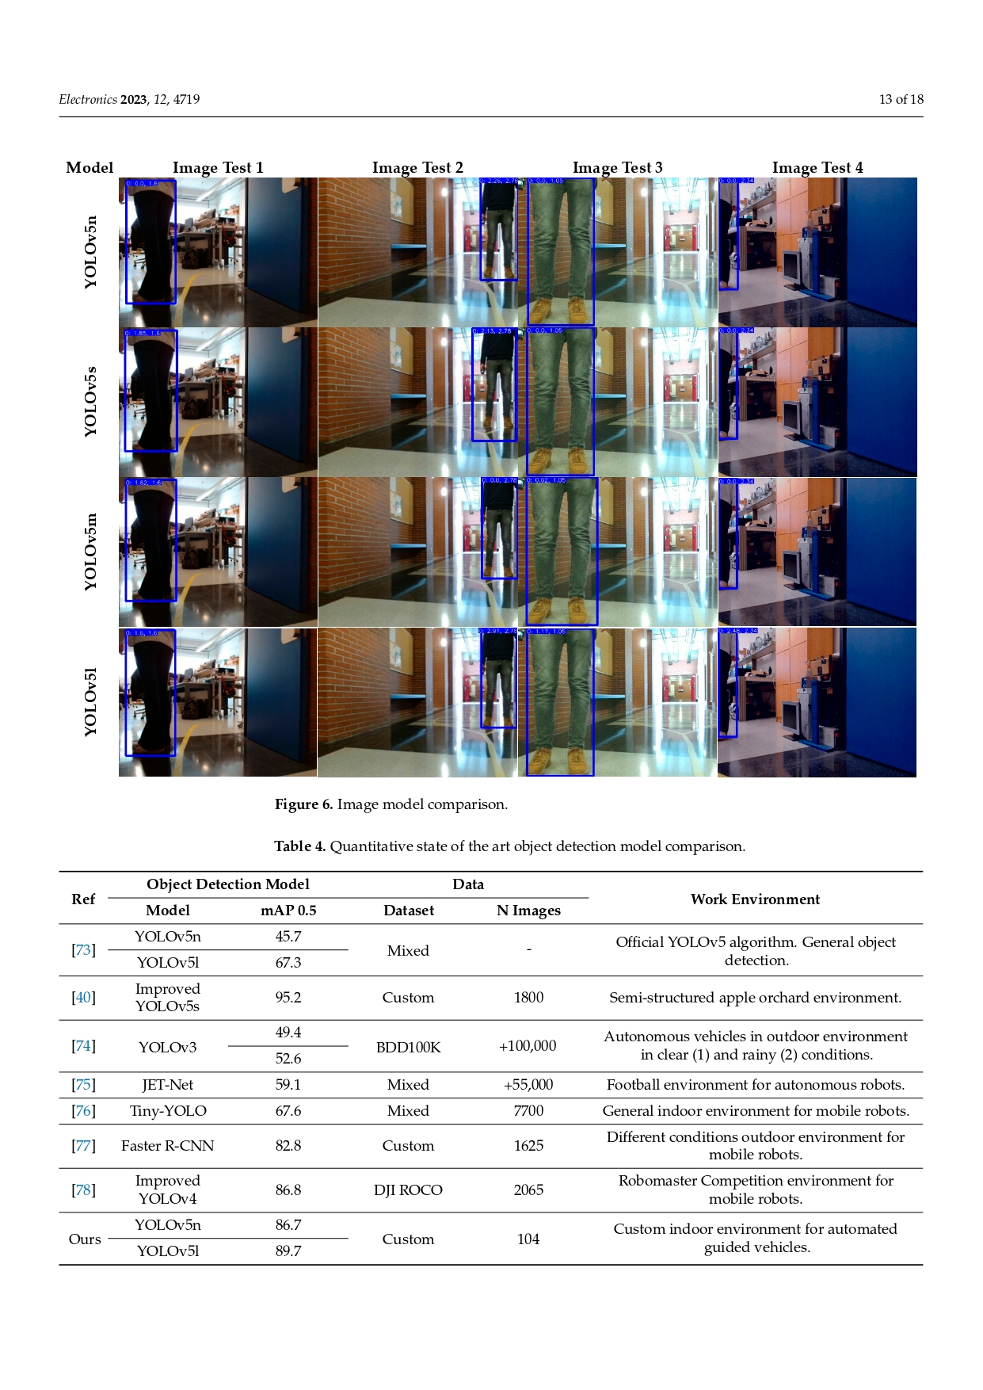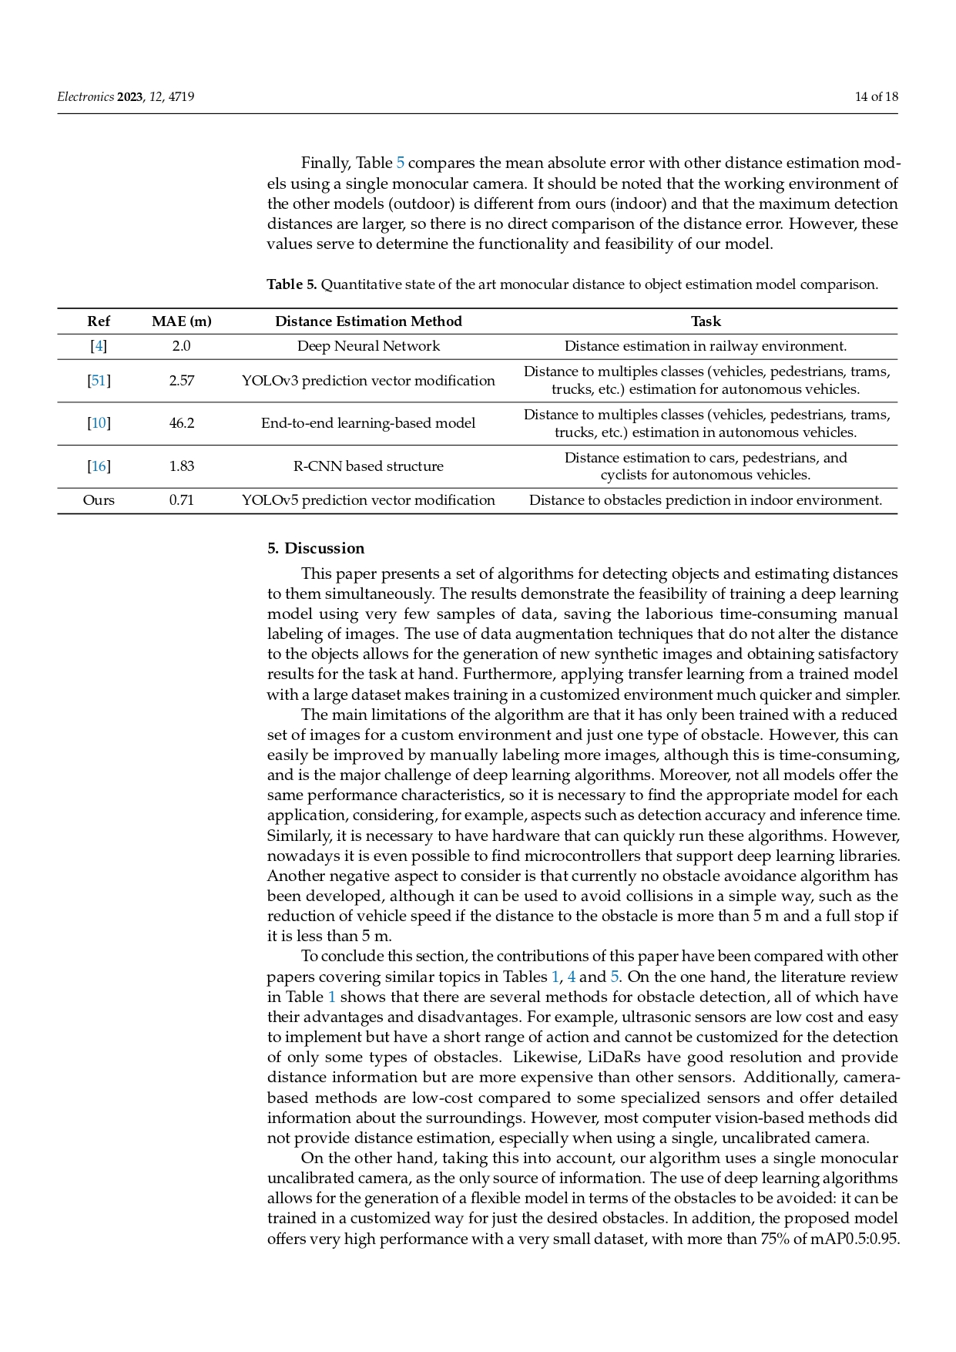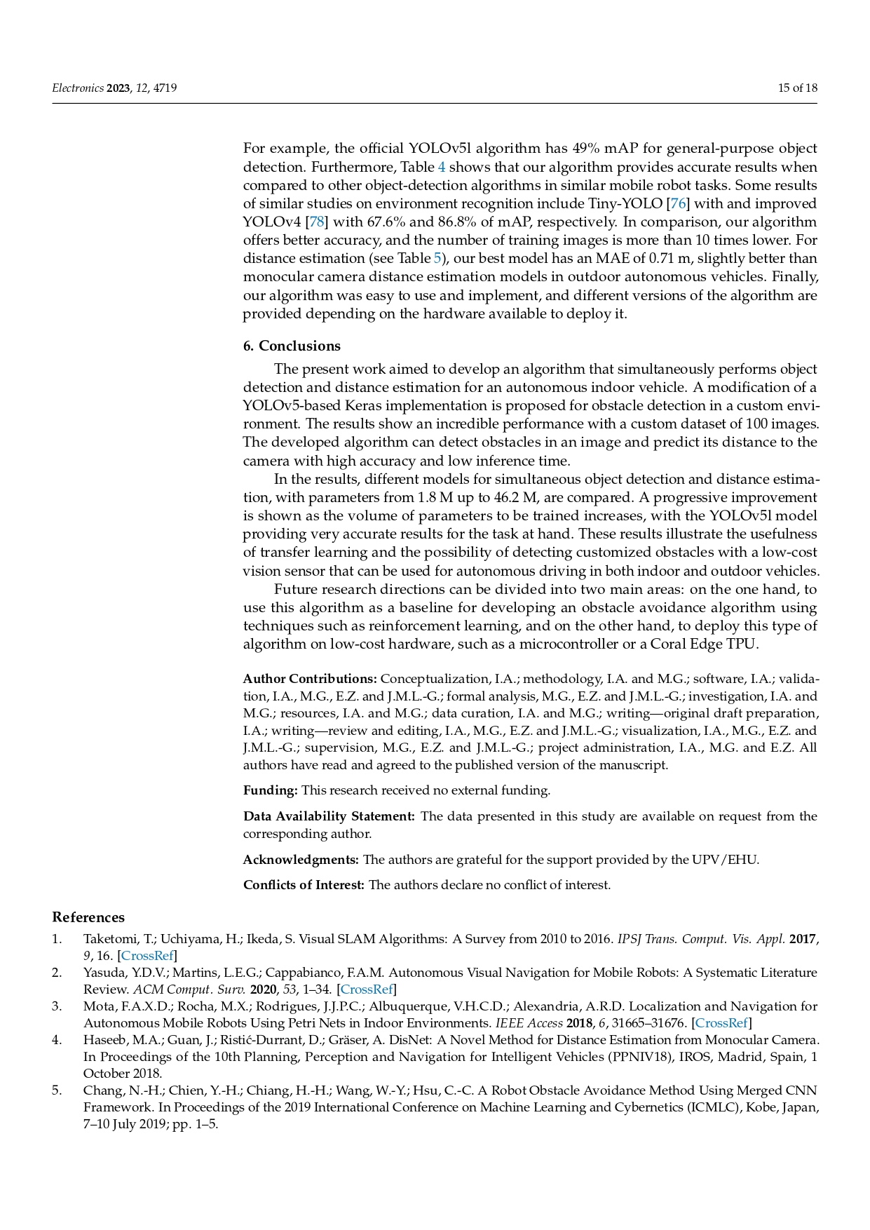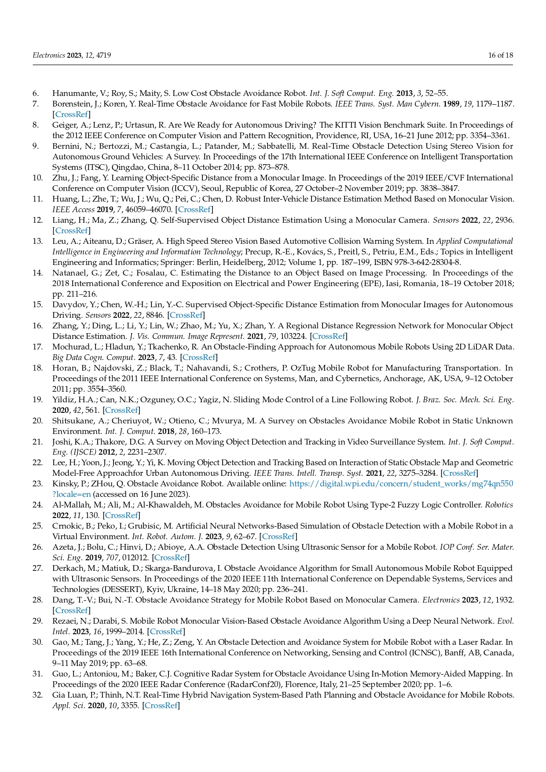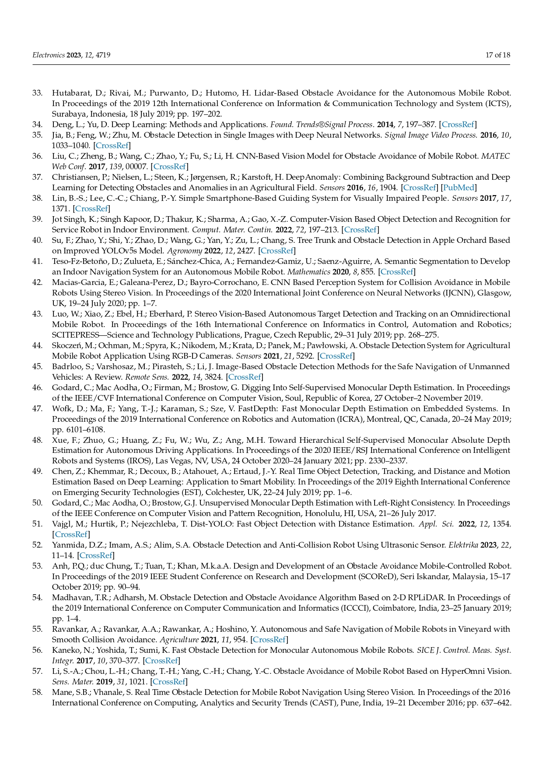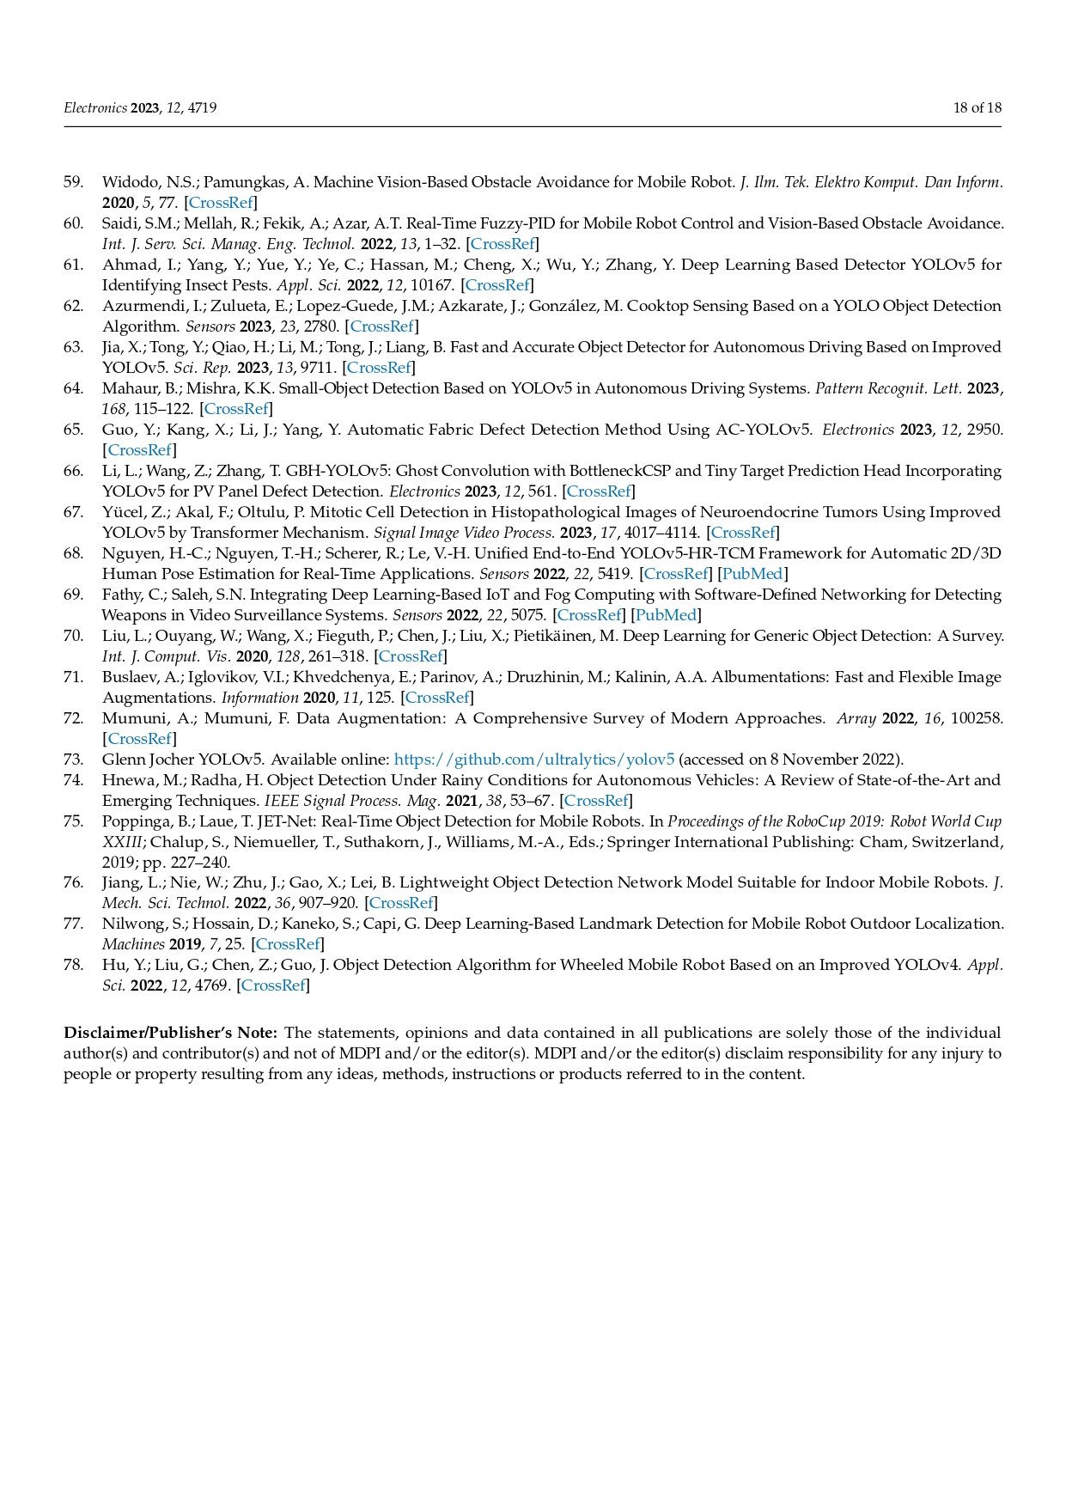

**7.2. Sample source code**

**7.2.1 YOLOv5s model**

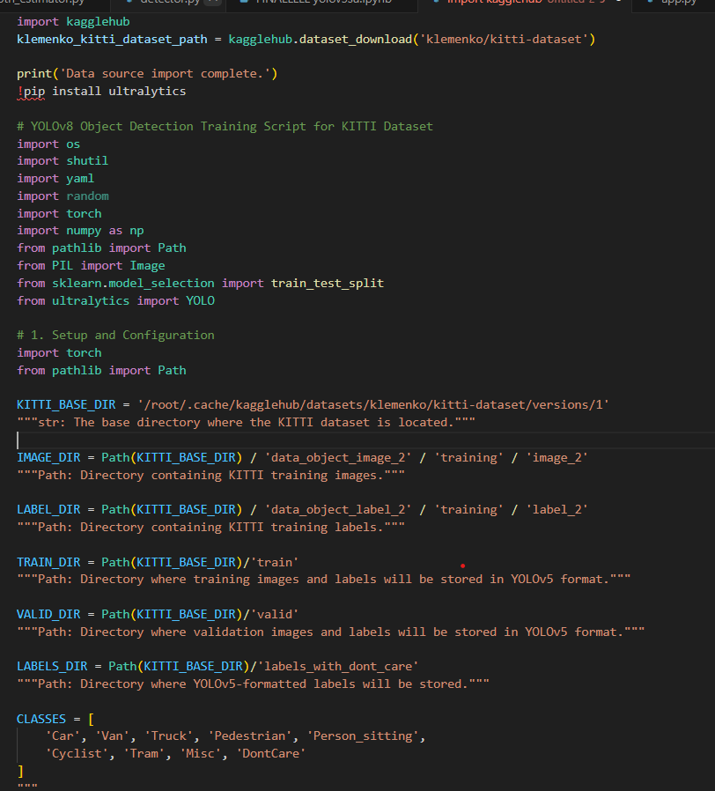

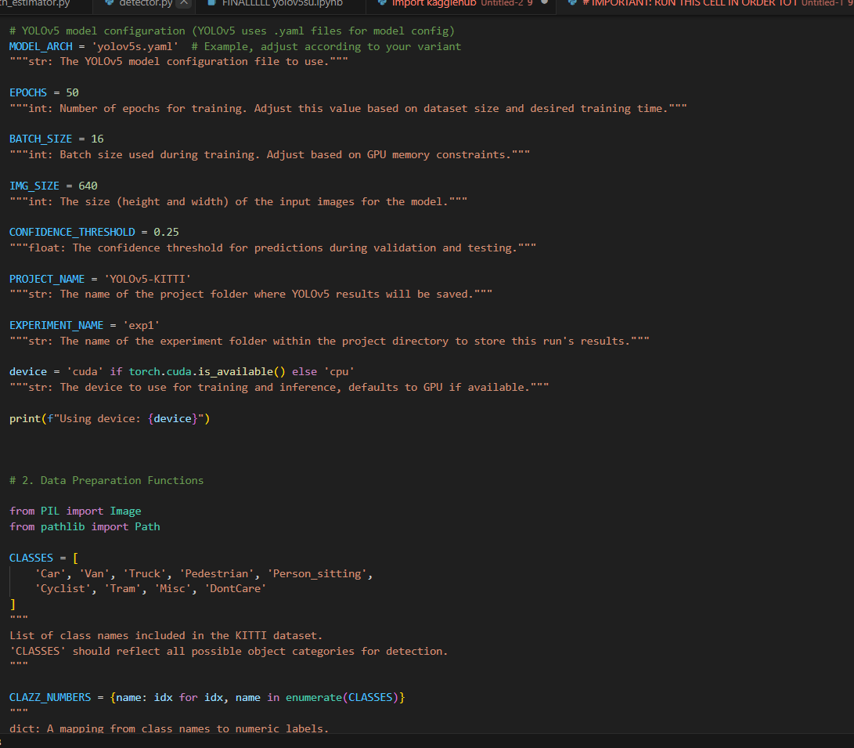

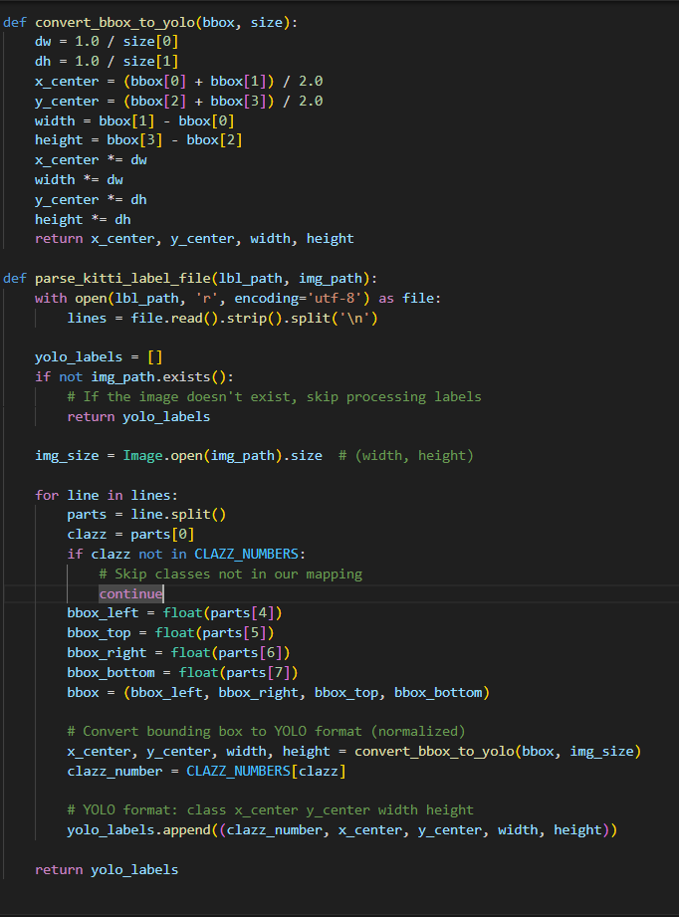

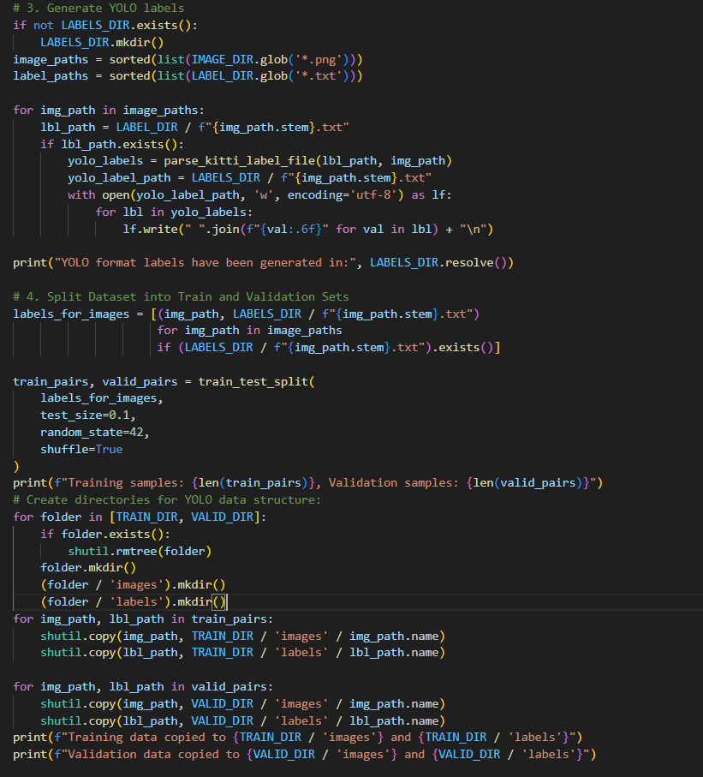

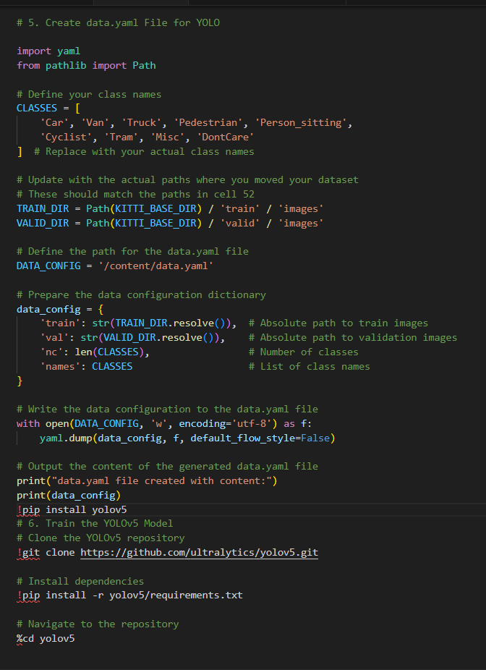

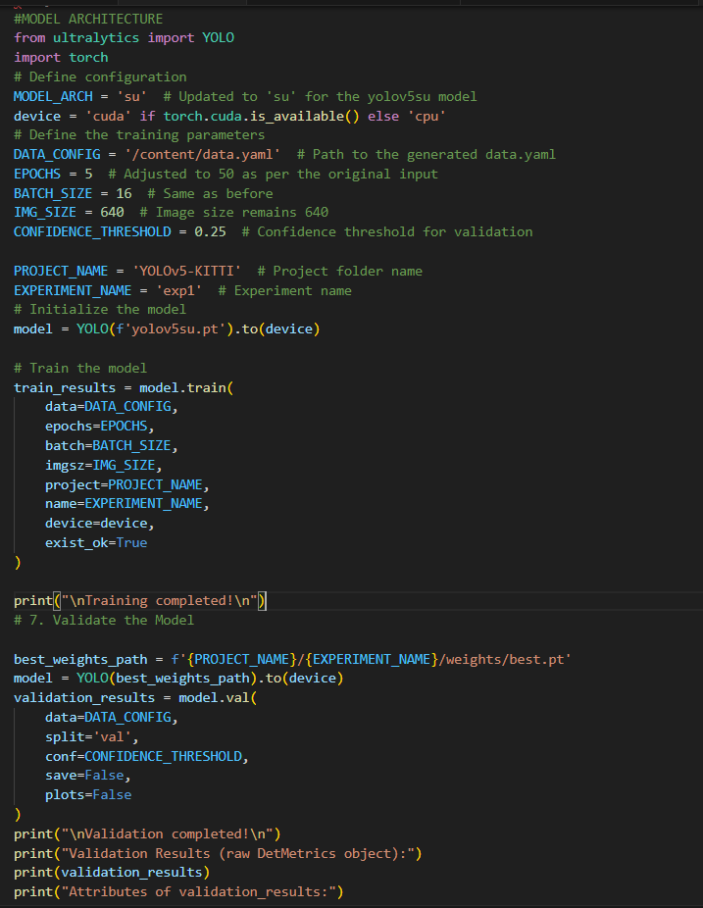

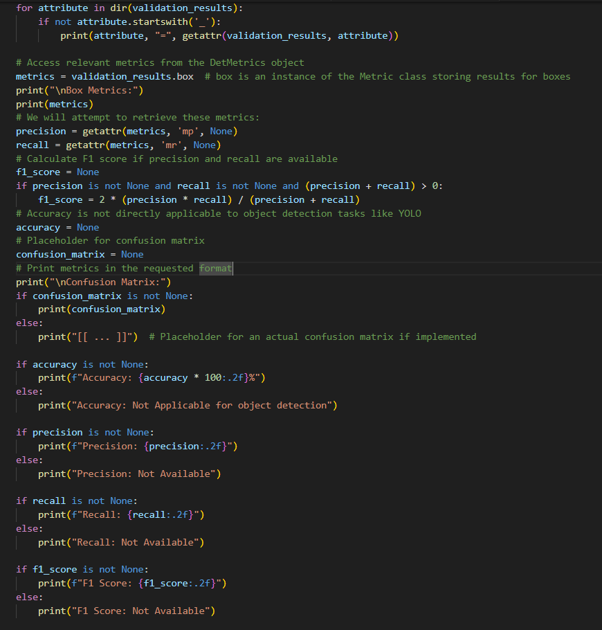

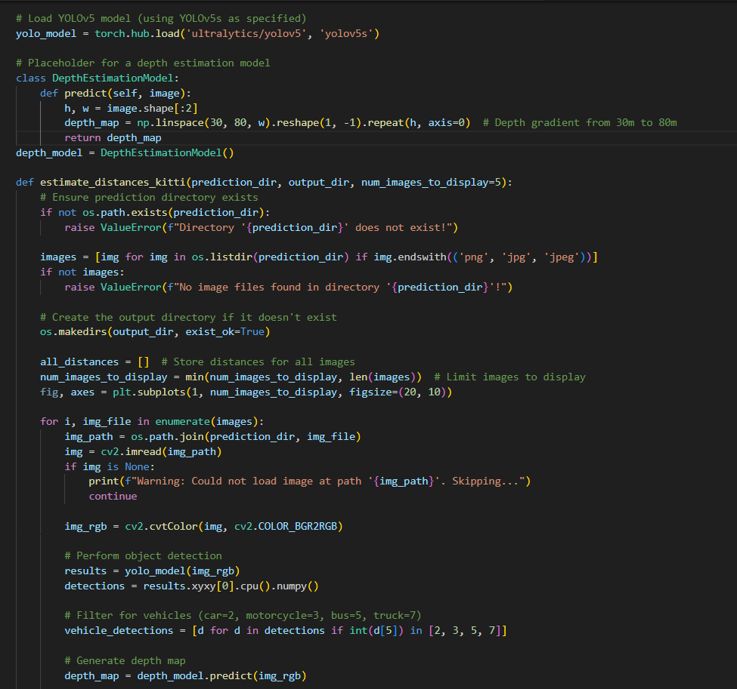

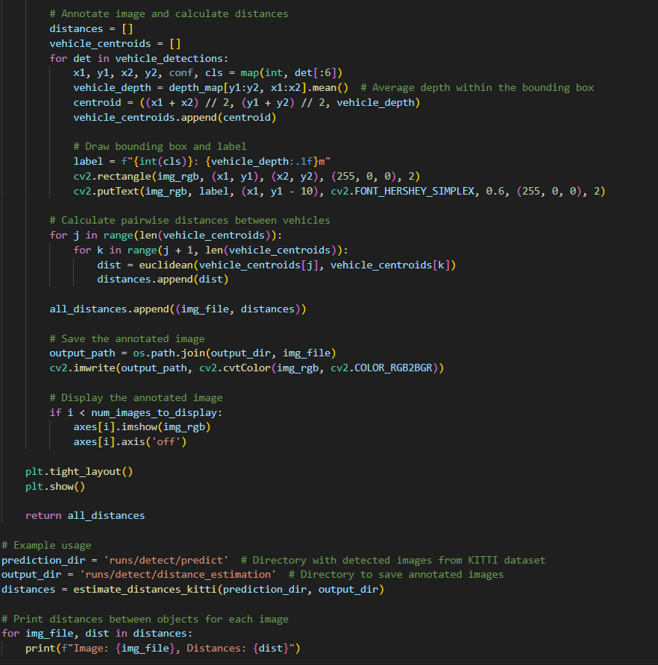

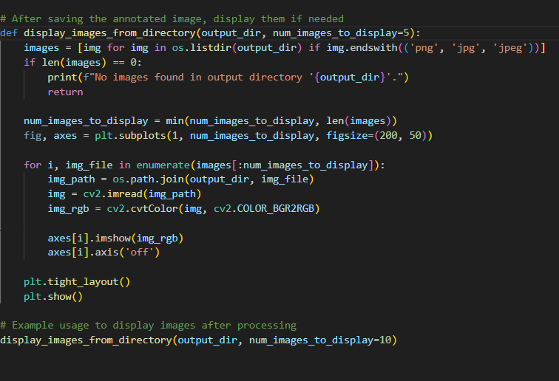

**7.2.2 YOLOv5m model**

Model Architecture code varies, remaining all same only

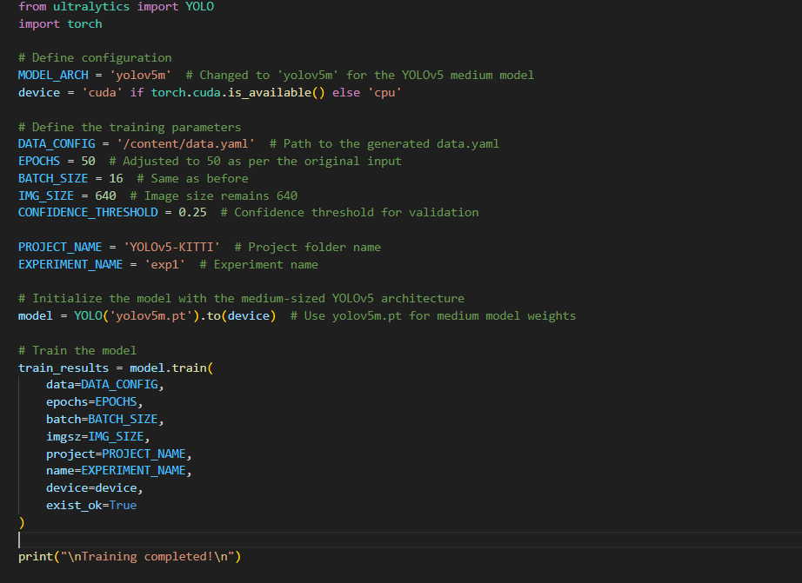

**7.2.3 YOLOv5n model**

Model Architecture code varies, remaining all same only

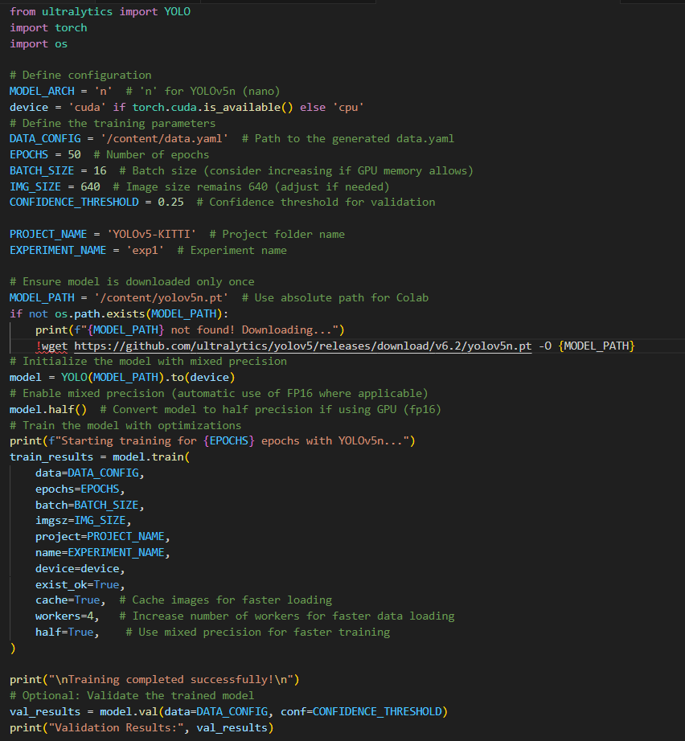

**7.2.4 YOLOv5l model**

Model Architecture code varies, remaining all same only

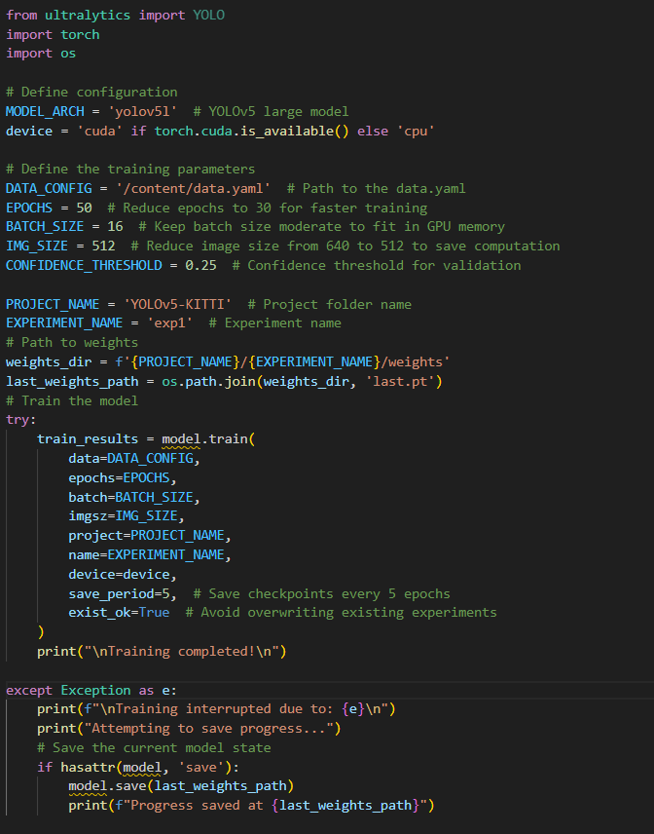

**7.2.5 YOLOv8n model**

Model Architecture code varies, remaining all same only

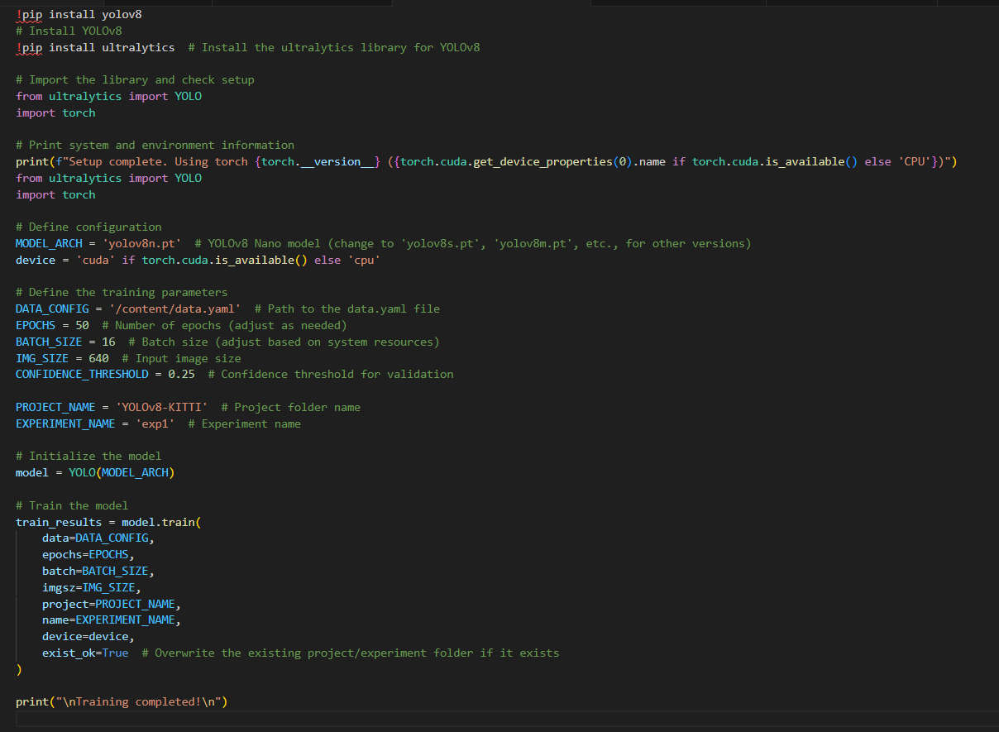

**7.2.6 SSD model**

Data preparation,Model Architecture codes vary, remaining all same only

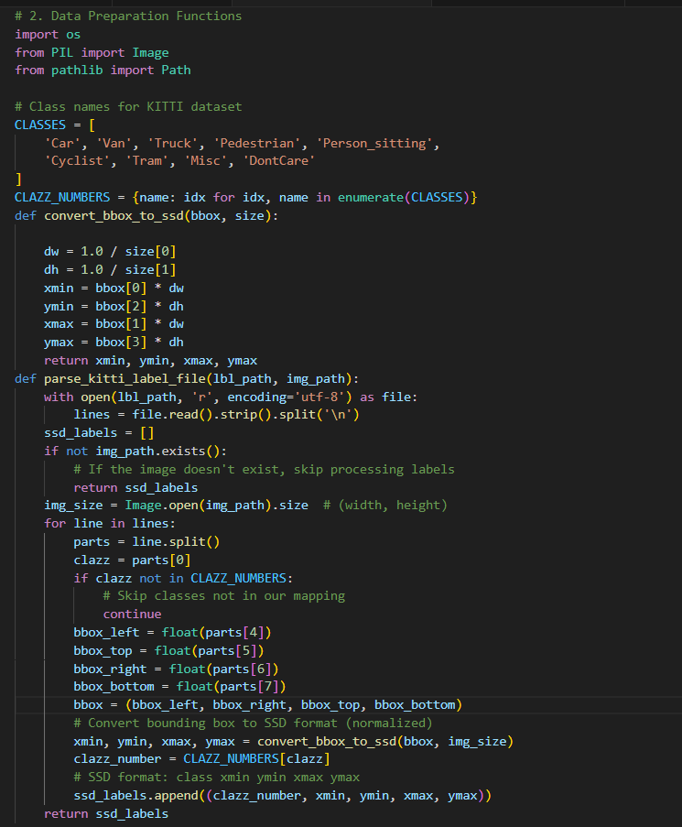

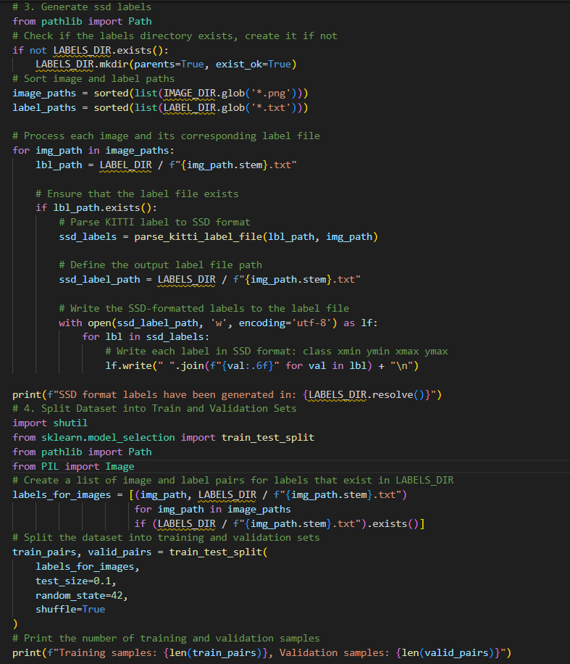

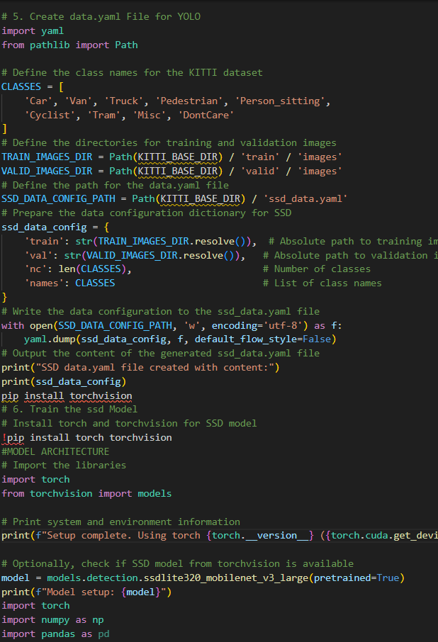

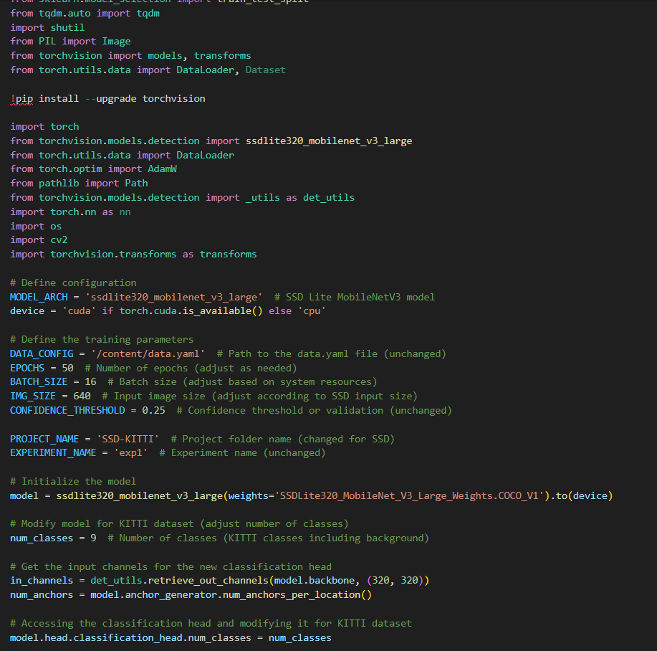

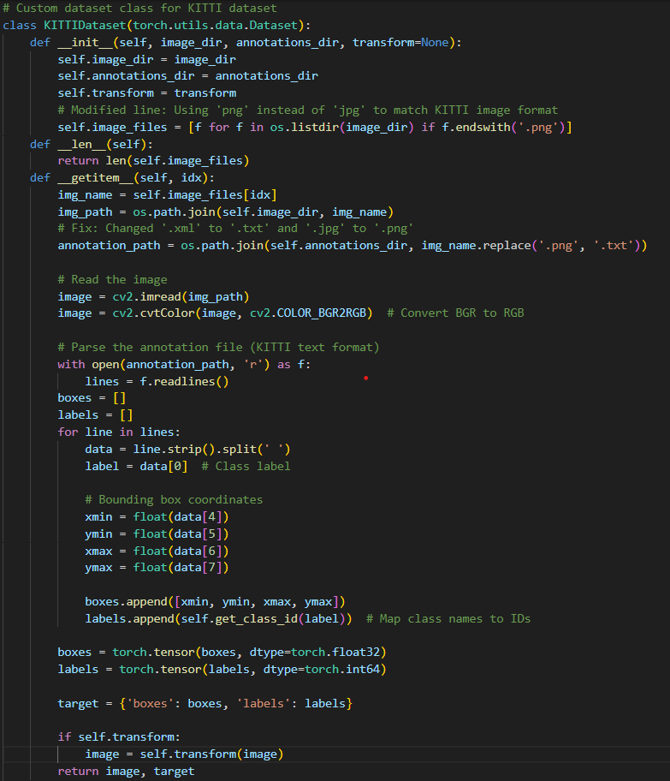

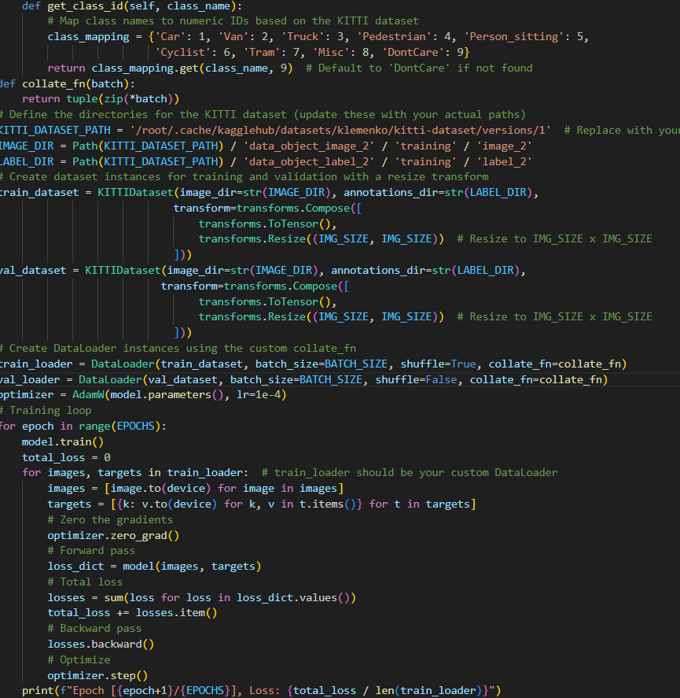

**7.2.7 Hybrid model YOLOv5+YOLOv8 (Custom dataset)**

FYI: Code remains same for KITTI dataset too, just dataset paths are changed.

